RANK | EARLY & MIDDLE GRADE
- Impossible Creatures
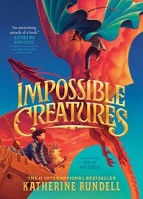



Katherine Rundell, Ashley Mackenzie (Illus.), Knopf Books for Young Readers, $19.99
- The Bletchley Riddle
Ruta Sepetys, Steve Sheinkin, Viking Books for Young Readers, $18.99
- The Squad: A Graphic Novel
Christina Soontornvat, Joanna Cacao (Illus.), Graphix, $12.99
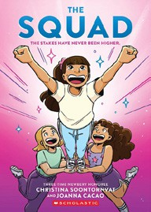

- The Millicent Quibb School of Etiquette for Young Ladies of Mad Science
Kate McKinnon, Little, Brown Books for Young Readers, $17.99
- Warriors Graphic Novel: The Prophecies Begin #1
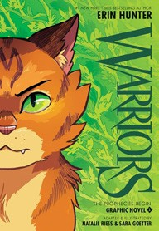

Erin Hunter, Natalie Riess (Illus.), Sara Goetter (Illus.), HarperAlley, $15.99
- The New Girl: A Graphic Novel
Cassandra Calin, Graphix, $12.99
- The Sherlock Society
James Ponti, Aladdin, $18.99
- The Eyes and the Impossible

Dave Eggers, Shawn Harris (Illus.), Knopf Books for Young Readers, $19.99
- Super Duper Extra Deluxe Essential Handbook (Pokémon)
Scholastic, $16.99
- The Last Dragon on Mars
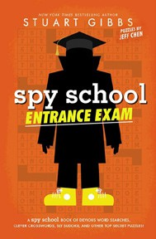
Scott Reintgen, Aladdin, $18.99
- Hatchet
Gary Paulsen, Simon & Schuster Books for Young Readers, $9.99
- Scholastic Year in Sports 2025
James Buckley, Scholastic, $14.99
- Bluey 5-Minute Stories
Penguin Young Readers, $14.99
- Spy School Entrance Exam
Stuart Gibbs, Jeff Chen, Simon & Schuster Books for Young Readers, $10.99
- Orris and Timble: The Beginning

Kate DiCamillo, Carmen Mok (Illus.), Candlewick, $16.99
Debut
Indies Introduce
January 1, 2025
For the week ending December 29, 2024 based on sales in hundreds of independent bookstores nationwide.
CHILDREN’S

RANK | YOUNG ADULT
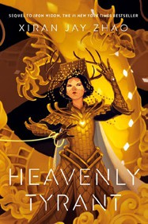
  - Heavenly Tyrant
Xiran Jay Zhao, Tundra Books, $20.99
  - Better Than the Movies
Lynn Painter, Simon & Schuster Books for Young Readers, $12.99
  - Powerless
Lauren Roberts, Simon & Schuster Books for Young Readers, $19.99
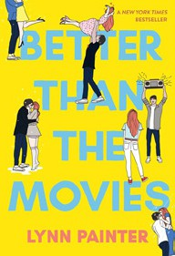

  - Nothing Like the Movies
Lynn Painter, Simon & Schuster Books for Young Readers, $19.99
  - Heir
Sabaa Tahir, G.P. Putnam’s Sons Books for Young Readers, $21.99
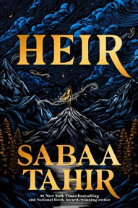

  - The Reappearance of Rachel Price
Holly Jackson, Delacorte Press, $20.99
  - If He Had Been with Me
Laura Nowlin, Sourcebooks Fire, $10.99
  - Pride and Prejudice
Jane Austen, Anna Bond (Illus.), Puffin Books, $17
  - If Only I Had Told Her
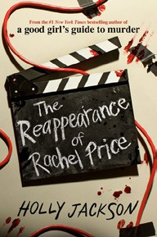

Laura Nowlin, Sourcebooks Fire, $12.99
  - The Grandest Game
Jennifer Lynn Barnes, Little, Brown Books for Young Readers, $19.99
  - Divine Rivals
Rebecca Ross, Wednesday Books, $18.99
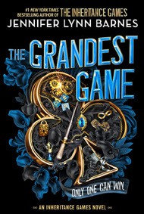

  - The Perks of Being a Wallflower
Stephen Chbosky, MTV Books, $15.99
  - Betting on You
Lynn Painter, Simon & Schuster Books for Young Readers, $12.99
  - Darkly
Marisha Pessl, Delacorte Press, $19.99
  - The Outsiders
S. E. Hinton, Viking Books for Young Readers, $14.99

OTHER CHILDREN’S INDIE FAVORITES
AGES 8 TO 12 TEEN READERS
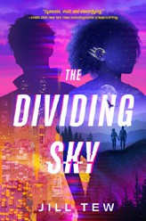

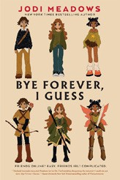

Bye Forever, I Guess
Jodi Meadows, Holiday House, $18.99
“Never want to say goodbye to Bye Forever, I Guess! The perfect middle grade novel about the changing nature of friendship, finding your fit while remaining true to yourself, and where to sit at lunch. Plus, a focus on nerdy girls rocks!”
—Susan Williams, M. Judson Booksellers & Storytellers, Greenville, SC
The Dividing Sky
Jill Tew, Joy Revolution, $19.99
“Jill Tew’s debut is everything readers have been waiting for.
I was completely sucked in! With its swoony romance, twisty plot, and all the thrills, it’s sure to make its way into the canon of YA dystopia.”
—Vania Stoyanova, Brave + Kind Bookshop, Decatur, GA

