RANK | FICTION
- James
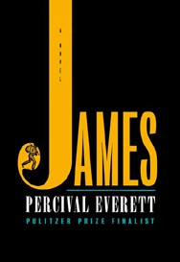



Percival Everett, Doubleday, $28
- Intermezzo
Sally Rooney, Farrar, Straus and Giroux, $29
- Small Things Like These
Claire Keegan, Grove Press, $20
- The God of the Woods
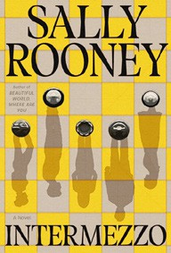

Liz Moore, Riverhead Books, $30
- The Women
Kristin Hannah, St. Martin’s Press, $30
- All Fours
Miranda July, Riverhead Books, $29
- The City and Its Uncertain Walls
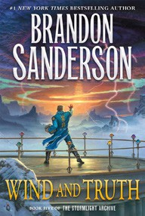

Haruki Murakami, Knopf, $35
- Playground
Richard Powers, W. W. Norton & Company, $29.99
- Wind and Truth
Brandon Sanderson, Tor Books, $39.99
- The Wedding People
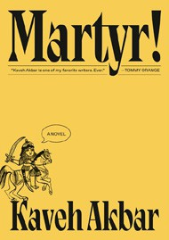

Alison Espach, Henry Holt and Co., $28.99
- The Grey Wolf
Louise Penny, Minotaur Books, $30
- Martyr!
Kaveh Akbar, Knopf, $28
- The Life Impossible
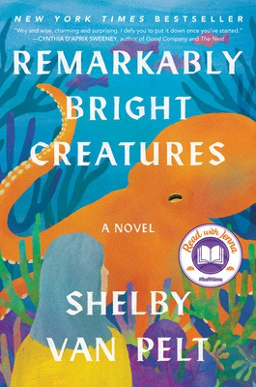

Matt Haig, Viking, $30
- Tell Me Everything
Elizabeth Strout, Random House, $30
- Remarkably Bright Creatures
Shelby Van Pelt, Ecco, $29.99
January 1, 2025
For the week ending December 29, 2024 based on sales in hundreds of independent bookstores nationwide.
HARDCOVER

RANK | NONFICTION
  - The Serviceberry: Abundance and Reciprocity in the Natural World
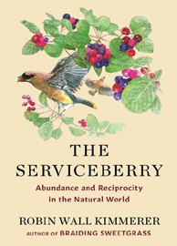

Robin Wall Kimmerer, John Burgoyne (Illus.), Scribner, $20
  - Be Ready When the Luck Happens: A Memoir
Ina Garten, Crown, $34
  - Revenge of the Tipping Point
Malcolm Gladwell, Little, Brown and Company, $32
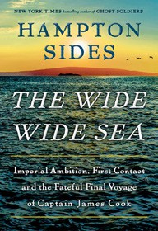

  - The Message
Ta-Nehisi Coates, One World, $30
  - Nexus: A Brief History of Information Networks from the Stone Age to AI Yuval Noah Harari, Random House, $35
  - What I Ate in One Year
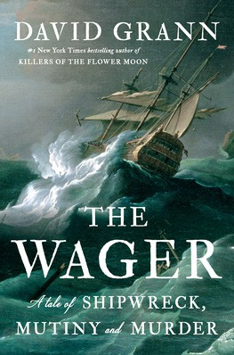

Stanley Tucci, Gallery Books, $35
  - The Demon of Unrest
Erik Larson, Crown, $35
  - The Wide Wide Sea
Hampton Sides, Doubleday, $35
  - The Creative Act: A Way of Being
Rick Rubin, Penguin Press, $32


  - The Wager
David Grann, Doubleday, $30
  - Patriot: A Memoir
Alexei Navalny, Knopf, $35
  - Cher: The Memoir, Part One
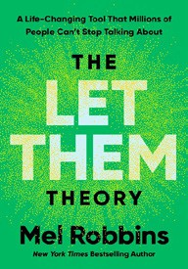

Cher, Dey Street Books, $36
  - Atomic Habits
James Clear, Avery, $27
  - Ottolenghi Comfort: A Cookbook
Yotam Ottolenghi, Ten Speed Press, $37.99
  - The Let Them Theory: A Life-Changing Tool That Millions of People Can’t Stop Talking About

Mel Robbins, Hay House LLC, $29.99
Debut
On the Rise

OTHER HARDCOVER INDIE FAVORITES
Indies Introduce

Sister Snake: A Novel
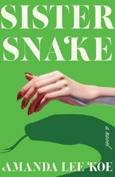

Amanda Lee Koe, Ecco, $28
“A unique book about two ancient sisters who are both human and snake. Su lives her life as humanly as possible; Emerald is very much herself. Though this novel was pitched as dark humor, it explored themes of identity, queerness, and family poignantly.”
—Sara Landon, Paragraphs Bookstore, Mount Vernon, OH
Shy Creatures: A Novel
Clare Chambers, Mariner Books, $30
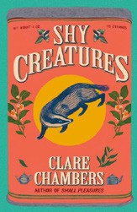

“An inventive and satisfying novel. Not just a story you’ll look forward to cozying up with, but a brilliant affirmation of non-conformity,
self-determination, and the power of art. For fans of Elizabeth McCracken, Tessa Hadley, and Ann Patchett!”
—Kristen Iskandrian, Thank You Books, Birmingham, AL

