RANK | HARDCOVER

- James




Percival Everett, Doubleday, $28
- Intermezzo
Sally Rooney, Farrar, Straus and Giroux, $29
- Small Things Like These
Claire Keegan, Grove Press, $20
- The God of the Woods
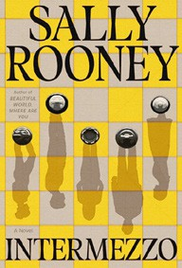

Liz Moore, Riverhead Books, $30
- The Women
Kristin Hannah, St. Martin’s Press, $30
- All Fours
Miranda July, Riverhead Books, $29
- The City and Its Uncertain Walls


Haruki Murakami, Knopf, $35
- Playground
Richard Powers, W. W. Norton & Company, $29.99
- Wind and Truth
Brandon Sanderson, Tor Books, $39.99
- The Wedding People
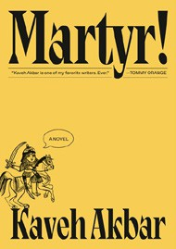

Alison Espach, Henry Holt and Co., $28.99
- The Grey Wolf
Louise Penny, Minotaur Books, $30
- Martyr!
Kaveh Akbar, Knopf, $28
- The Life Impossible
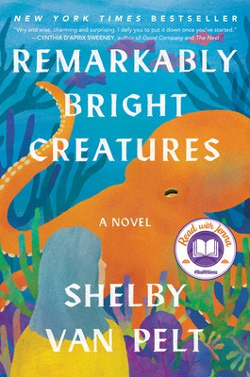

Matt Haig, Viking, $30
- Tell Me Everything
Elizabeth Strout, Random House, $30
- Remarkably Bright Creatures
Shelby Van Pelt, Ecco, $29.99
January 1, 2025
For the week ending December 29, 2024 based on sales in hundreds of independent bookstores nationwide.
FICTION

RANK | PAPERBACK
  - Demon Copperhead
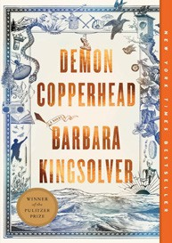

Barbara Kingsolver, Harper Perennial, $21.99
  - Orbital
Samantha Harvey, Grove Press, $17
  - The Frozen River
Ariel Lawhon, Vintage, $18
  - Fourth Wing


Rebecca Yarros, Entangled: Red Tower Books, $20.99
  - A Court of Thorns and Roses
Sarah J. Maas, Bloomsbury Publishing, $19
  - North Woods
Daniel Mason, Random House Trade Paperbacks, $18
  - Tomorrow, and Tomorrow, and Tomorrow


Gabrielle Zevin, Vintage, $19
  - Wicked
Gregory Maguire, William Morrow Paperbacks, $19.99
  - The Berry Pickers
Amanda Peters, Catapult, $17.95
  - Hello Beautiful
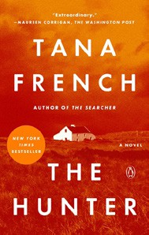

Ann Napolitano, Dial Press Trade Paperback, $18.99
  - The Thursday Murder Club
Richard Osman, Penguin, $18
  - The Hunter
Tana French, Penguin, $19
  - The Best American Short Stories 2024


Lauren Groff, Heidi Pitlor (Eds.), Mariner Books,
$19.99
  - The Vegetarian
Han Kang, Hogarth, $17
  - The Housemaid
Freida McFadden, Grand Central, $12.99

Debut
On the Rise Indies Introduce

