RANK | ILLUSTRATED
- How the Grinch Stole Christmas!
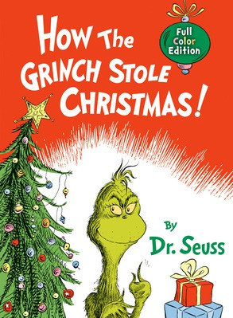



Dr. Seuss, Random House Books for Young Readers,
$19.99
- The Polar Express
Chris Van Allsburg, HMH Books for Young Readers,
$21.99
- The Snowy Day
Ezra Jack Keats, Viking Books for Young Readers,
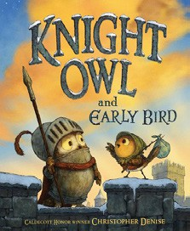

$19.99
- Knight Owl and Early Bird
Christopher Denise, Christy Ottaviano Books, $18.99
- How Does Santa Go Down the Chimney?
Mac Barnett, Jon Klassen (Illus.), Candlewick, $18.99
- Santa’s First Christmas
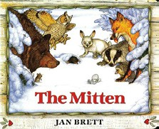

Mac Barnett, Sydney Smith (Illus.), Viking Books for Young Readers, $18.99
- Goodnight Moon
Margaret Wise Brown, Clement Hurd (Illus.), Harper,
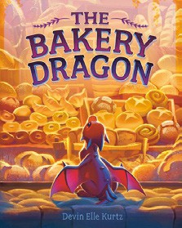

$10.99
- Alice in a Winter Wonderland
Jan Brett, G.P. Putnam’s Sons Books for Young Readers, $19.99
- The Mitten
Jan Brett, G.P. Putnam’s Sons Books for Young Readers, $9.99
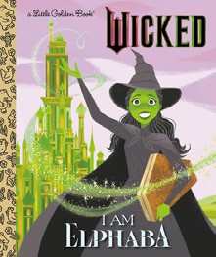

- The Bakery Dragon
Devin Elle Kurtz, Knopf Books for Young Readers,
$18.99
- Where the Wild Things Are
Maurice Sendak, Harper, $21.99
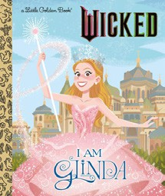
- I Am Elphaba (Little Golden Book)
Mary Man-Kong, Elsa Chang (Illus.), Golden Books,
$5.99
- The Very Hungry Caterpillar
Eric Carle, World of Eric Carle, $10.99
- Knight Owl
Christopher Denise, Christy Ottaviano Books, $17.99
- I Am Glinda (Little Golden Book)

Mary Man-Kong, Elsa Chang (Illus.), Golden Books,
$5.99
January 1, 2025
For the week ending December 29, 2024 based on sales in hundreds of independent bookstores nationwide.
CHILDREN’S

RANK | SERIES
  - Dog Man (hardcover)
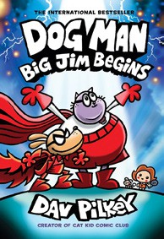

Dav Pilkey, Graphix
  - Diary of a Wimpy Kid (hardcover)
Jeff Kinney, Harry N. Abrams
  - Wings of Fire
Tui T. Sutherland, Mike Holmes (Illus.), Scholastic New in Series: Escaping Peril: A Graphic Novel
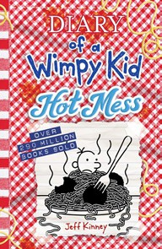

  - The Wild Robot
Peter Brown, Little, Brown Books for Young Readers
  - Percy Jackson and the Olympians
Rick Riordan, Hyperion
  - Elephant & Piggie (hardcover)
Mo Willems, Hyperion
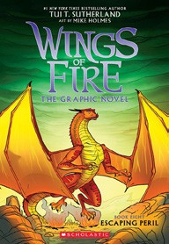

  - I Survived
Lauren Tarshis, Dave Shephard (Illus.), Scholastic
  - Keeper of the Lost Cities
Shannon Messenger, Aladdin
  - The Bad Guys (paperback)
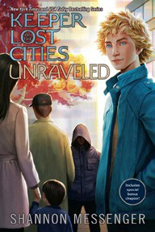

Aaron Blabey, Scholastic
  - InvestiGators (hardcover)
John Patrick Green, First Second

All Fiction Series titles are hardcover and
paperback unless noted.
Debut


Indies Introduce

OTHER CHILDREN’S INDIE FAVORITES
AGES 4 TO 8
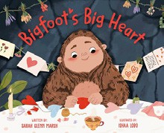

Bigfoot’s Big Heart
Sarah Glenn Marsh, Ishaa Lobo (Illus.), Viking Books for Young Readers, $18.99
“This is adorable! Bigfoot and all the cryptids around the globe find some unexpected (and very determined) allies in scouting kids worldwide. Here’s a perfect Valentine for all the introverts or shy kids or delightful weirdos!”
—Tegan Tigani, Queen Anne Book Company, Seattle, WA

