RANK | FICTION
- Orbital
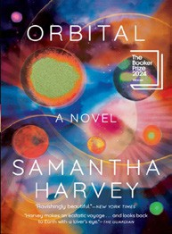



Samantha Harvey, Grove Press, $17
- The Frozen River
Ariel Lawhon, Vintage, $18
- Demon Copperhead
Barbara Kingsolver, Harper Perennial, $21.99
- Wicked
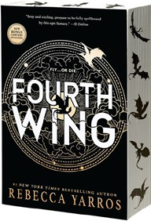

Gregory Maguire, William Morrow Paperbacks,
$19.99
- North Woods
Daniel Mason, Random House Trade Paperbacks,
$18
- Fourth Wing


Rebecca Yarros, Entangled: Red Tower Books, $20.99
- The Berry Pickers
Amanda Peters, Catapult, $17.95
- Tomorrow, and Tomorrow, and Tomorrow
Gabrielle Zevin, Vintage, $19
- A Court of Thorns and Roses
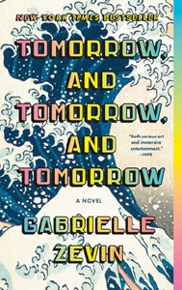

Sarah J. Maas, Bloomsbury Publishing, $19
- The Hunter
Tana French, Penguin, $19
- Hello Beautiful
Ann Napolitano, Dial Press Trade Paperback,
$18.99
- The Thursday Murder Club


Richard Osman, Penguin, $18
- Devotions
Mary Oliver, Penguin, $20
- The Best American Short Stories 2024
Lauren Groff, Heidi Pitlor (Eds.), Mariner Books,
$19.99
- The Vegetarian
Han Kang, Hogarth, $17

OTHER PAPERBACK INDIE FAVORITES
An Earthquake Is a Shaking of the Surface of the Earth: A Novel


Anna Moschovakis, Soft Skull, $16.95
“A glimpse into the fractured psyche of a former actress living in a city where the Earth shakes. The dystopian otherworldliness takes a backseat to the obsessive unwellness of our unnamed narrator. Part sci-fi, part mystery, deeply literary.”
—Andrew Preston, CoffeeTree Books, Morehead, KY
December 18, 2024
For the week ending December 15, 2024 based on sales in hundreds of independent bookstores nationwide.
PAPERBACK

RANK | NONFICTION
  - The Backyard Bird Chronicles


Amy Tan, Knopf, $35
  - Braiding Sweetgrass
Robin Wall Kimmerer, Milkweed Editions, $20
  - On Tyranny
Timothy Snyder, Crown, $12
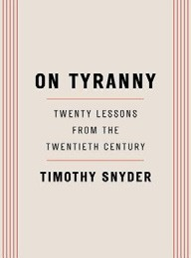

  - The Art Thief
Michael Finkel, Vintage, $18
  - Say Nothing
Patrick Radden Keefe, Vintage, $20
  - The 2025 Old Farmer’s Almanac
Old Farmer’s Almanac, $10.95
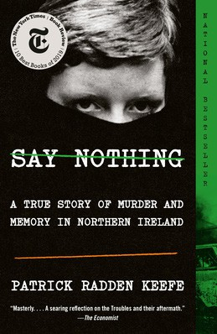

  - Democracy Awakening
Heather Cox Richardson, Penguin, $18
  - All About Love: New Visions
bell hooks, Morrow, $16.99
  - Greenlights
Matthew McConaughey, Crown, $20
  - The Field Guide to Dumb Birds of North America
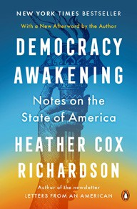

Matt Kracht, Chronicle, $15.95
  - The Hundred Years’ War on Palestine
Rashid Khalidi, Metropolitan Books, $19.99
  - The Body Keeps the Score
Bessel van der Kolk, M.D., Penguin, $19
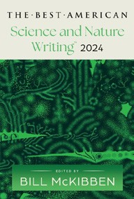

  - All the Beauty in the World: The Metropolitan Museum of Art and Me Patrick Bringley, Simon & Schuster, $18.99
  - World Travel: An Irreverent Guide
Anthony Bourdain, Laurie Woolever, Ecco, $22
  - The Best American Science and Nature Writing 2024
Bill McKibben, Jaime Green (Eds.), Mariner Books,
$18.99 Debut
On the Rise

MASS MARKET Indies Introduce
- 1984 George Orwell, Signet, $10.99
- The Way of Kings Brandon Sanderson, Tor, $12.99
- Mistborn: The Final Empire Brandon Sanderson, Tor, $10.99
- Animal Farm George Orwell, Signet, $9.99
- The Exchange John Grisham, Vintage, $10.99
- Dune Frank Herbert, Ace, $10.99
- The Name of the Wind Patrick Rothfuss, DAW, $10.99
- The Hitchhiker’s Guide to the Galaxy Douglas Adams, Del Rey, $8.99
- Rhythm of War Brandon Sanderson, Tor, $12.99
- The Diary of a Young Girl Anne Frank, Bantam, $8.99

