RANK | HARDCOVER

- The Serviceberry: Abundance and Reciprocity in the Natural World




Robin Wall Kimmerer, John Burgoyne (Illus.), Scribner, $20
- Be Ready When the Luck Happens: A Memoir
Ina Garten, Crown, $34
- The Message
Ta-Nehisi Coates, One World, $30


- Revenge of the Tipping Point
Malcolm Gladwell, Little, Brown and Company, $32
- The Demon of Unrest
Erik Larson, Crown, $35
- What I Ate in One Year
Stanley Tucci, Gallery Books, $35


- The Wide Wide Sea
Hampton Sides, Doubleday, $35
- Cher: The Memoir, Part One
Cher, Dey Street Books, $36
- The Wager
David Grann, Doubleday, $30


- Nexus
Yuval Noah Harari, Random House, $35
- The Creative Act: A Way of Being
Rick Rubin, Penguin Press, $32
- What the Chicken Knows

Sy Montgomery, Atria Books, $22.99
- Taylor Swift by the Book: The Literature Behind the Lyrics, from Fairy Tales
to Tortured Poets
Rachel Feder, Tiffany Tatreau, Quirk Books, $19.99
- CABIN: Off the Grid Adventures with a Clueless Craftsman
Patrick Hutchison, St. Martin’s Press, $29
- Patriot: A Memoir
Alexei Navalny, Knopf, $35
December 18, 2024
For the week ending December 15, 2024 based on sales in hundreds of independent bookstores nationwide.
NONFICTION

RANK | PAPERBACK

  - The Backyard Bird Chronicles


Amy Tan, Knopf, $35
  - Braiding Sweetgrass
Robin Wall Kimmerer, Milkweed Editions, $20
  - On Tyranny
Timothy Snyder, Crown, $12
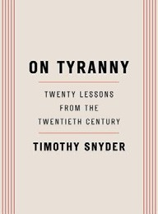

  - The Art Thief
Michael Finkel, Vintage, $18
  - Say Nothing
Patrick Radden Keefe, Vintage, $20
  - The 2025 Old Farmer’s Almanac
Old Farmer’s Almanac, $10.95
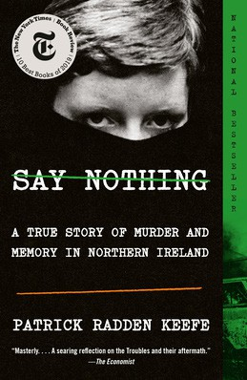

  - Democracy Awakening
Heather Cox Richardson, Penguin, $18
  - All About Love: New Visions
bell hooks, Morrow, $16.99
  - Greenlights
Matthew McConaughey, Crown, $20
  - The Field Guide to Dumb Birds of North America
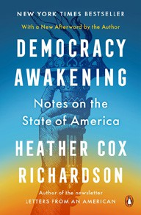

Matt Kracht, Chronicle, $15.95
  - The Hundred Years’ War on Palestine
Rashid Khalidi, Metropolitan Books, $19.99
  - The Body Keeps the Score
Bessel van der Kolk, M.D., Penguin, $19
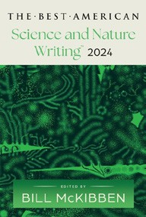

  - All the Beauty in the World: The Metropolitan Museum of Art and Me Patrick Bringley, Simon & Schuster, $18.99
  - World Travel: An Irreverent Guide
Anthony Bourdain, Laurie Woolever, Ecco, $22
  - The Best American Science and Nature Writing 2024
Bill McKibben, Jaime Green (Eds.), Mariner Books,
$18.99

Debut
On the Rise Indies Introduce

