RANK | FICTION
- James
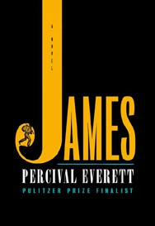



Percival Everett, Doubleday, $28
- Small Things Like These
Claire Keegan, Grove Press, $20
- The God of the Woods
Liz Moore, Riverhead Books, $30
- Wind and Truth
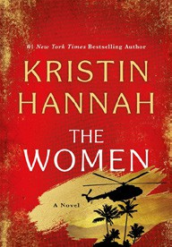

Brandon Sanderson, Tor Books, $39.99
- The Women
Kristin Hannah, St. Martin’s Press, $30
- Intermezzo
Sally Rooney, Farrar, Straus and Giroux, $29
- The City and Its Uncertain Walls


Haruki Murakami, Knopf, $35
- All Fours
Miranda July, Riverhead Books, $29
- Playground
Richard Powers, W. W. Norton & Company, $29.99
- The Grey Wolf


Louise Penny, Minotaur Books, $30
- The Wedding People
Alison Espach, Henry Holt and Co., $28.99
- Tell Me Everything
Elizabeth Strout, Random House, $30
- Martyr!
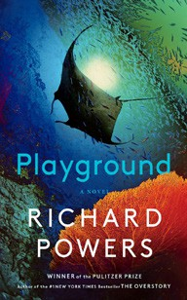

Kaveh Akbar, Knopf, $28
- The Mighty Red
Louise Erdrich, Harper, $32
- We Solve Murders
Richard Osman, Pamela Dorman Books, $30
December 18, 2024
For the week ending December 15, 2024 based on sales in hundreds of independent bookstores nationwide.
HARDCOVER

RANK | NONFICTION
  - The Serviceberry: Abundance and Reciprocity in the Natural World
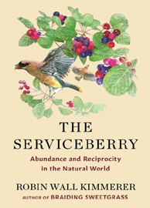

Robin Wall Kimmerer, John Burgoyne (Illus.), Scribner, $20
  - Be Ready When the Luck Happens: A Memoir
Ina Garten, Crown, $34
  - The Message
Ta-Nehisi Coates, One World, $30
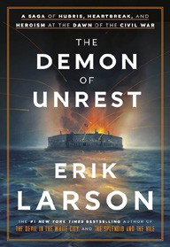

  - Revenge of the Tipping Point
Malcolm Gladwell, Little, Brown and Company, $32
  - The Demon of Unrest
Erik Larson, Crown, $35
  - What I Ate in One Year
Stanley Tucci, Gallery Books, $35
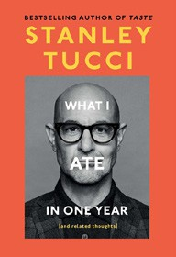

  - The Wide Wide Sea
Hampton Sides, Doubleday, $35
  - Cher: The Memoir, Part One
Cher, Dey Street Books, $36
  - The Wager
David Grann, Doubleday, $30


  - Nexus
Yuval Noah Harari, Random House, $35
  - The Creative Act: A Way of Being
Rick Rubin, Penguin Press, $32
  - What the Chicken Knows
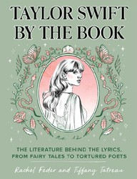
Sy Montgomery, Atria Books, $22.99
  - Taylor Swift by the Book: The Literature Behind the Lyrics, from Fairy Tales
to Tortured Poets
Rachel Feder, Tiffany Tatreau, Quirk Books, $19.99
  - CABIN: Off the Grid Adventures with a Clueless Craftsman
Patrick Hutchison, St. Martin’s Press, $29
  - Patriot: A Memoir
Alexei Navalny, Knopf, $35

OTHER HARDCOVER INDIE FAVORITES
Debut
On the Rise

Indies Introduce

Only Here, Only Now: A Novel
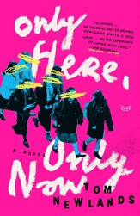

Tom Newlands, HarperVia, $28.99
“This debut is the thunderous announcement of a brilliant novelist with a keen wit. Like Derry Girls done by Dave Eggers, Only Here, Only Now is fiercely original, unabashedly Scottish, heartrendingly poignant, and hilarious to the point of tears.”
—Steve Iwanski, Charter Books, Newport, RI
I Might Be in Trouble: A Novel
Daniel Aleman, Grand Central Publishing, $29
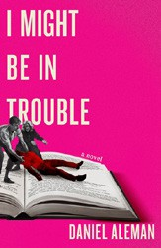

“Daniel Aleman nailed his adult debut. This book was funny, relat- able, heart-wrenching, and heart-stopping. I’d recommend this book to damn near anyone — especially anyone who feels adrift and is looking for a book that will make them feel hopeful.”
—Renee Becher, The Crowded Bookshelf, Fort Collins, CO

