RANK | FICTION
- Demon Copperhead
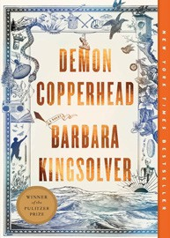



Barbara Kingsolver, Harper Perennial, $21.99
- Orbital
Samantha Harvey, Grove Press, $17
- The Frozen River
Ariel Lawhon, Vintage, $18
- North Woods


Daniel Mason, Random House Trade Paperbacks,
$18
- Fourth Wing
Rebecca Yarros, Entangled: Red Tower Books, $20.99
- The Berry Pickers
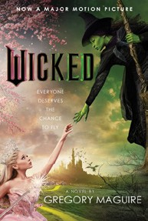
Amanda Peters, Catapult, $17.95
- Wicked
Gregory Maguire, William Morrow Paperbacks, $19.99
- A Court of Thorns and Roses
Sarah J. Maas, Bloomsbury Publishing, $19
- Hello Beautiful
Ann Napolitano, Dial Press Trade Paperback, $18.99


- Tomorrow, and Tomorrow, and Tomorrow
Gabrielle Zevin, Vintage, $19
- The Vegetarian
Han Kang, Hogarth, $17
- The Christmas Tree Farm
Laurie Gilmore, One More Chapter, $18.99
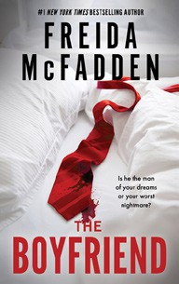

- The Boyfriend
Freida McFadden, Poisoned Pen Press, $17.99
- The Best American Short Stories 2024
Lauren Groff, Heidi Pitlor (Eds.), Mariner Books, $19.99
- The Housemaid
Freida McFadden, Grand Central, $12.99
December 4, 2024
For the week ending December 1, 2024 based on sales in hundreds of independent bookstores nationwide.
PAPERBACK

RANK | NONFICTION
  - The Backyard Bird Chronicles


Amy Tan, Knopf, $35
  - Braiding Sweetgrass
Robin Wall Kimmerer, Milkweed Editions, $20
  - The Art Thief
Michael Finkel, Vintage, $18
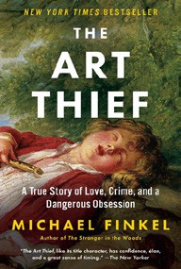

  - On Tyranny: Twenty Lessons from the Twentieth Century
Timothy Snyder, Crown, $12
  - Say Nothing: A True Story of Murder and Memory in Northern Ireland
Patrick Radden Keefe, Vintage, $20
  - Democracy Awakening


Heather Cox Richardson, Penguin, $18
  - Greenlights
Matthew McConaughey, Crown, $20
  - All About Love: New Visions
bell hooks, Morrow, $16.99
  - The 2025 Old Farmer’s Almanac
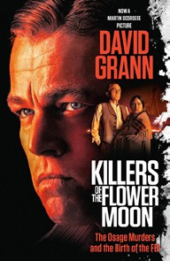

Old Farmer’s Almanac, $10.95
  - The Hundred Years’ War on Palestine
Rashid Khalidi, Metropolitan Books, $19.99
  - The Body Keeps the Score
Bessel van der Kolk, M.D., Penguin, $19
  - The Field Guide to Dumb Birds of North America
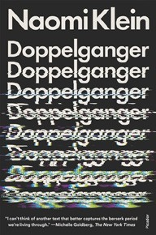

Matt Kracht, Chronicle, $15.95
  - Killers of the Flower Moon
David Grann, Vintage, $18
  - Crying in H Mart: A Memoir
Michelle Zauner, Vintage, $17
  - Doppelganger: A Trip into the Mirror World
Naomi Klein, Picador, $20

OTHER PAPERBACK INDIE FAVORITES
Sundown in San Ojuela: A Novel
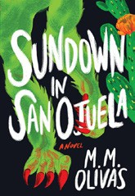

M. M. Olivas, Lanternfish Press, $19
“Wow! It’s been so long since I read a book that got this deep into me and did not let go. I loved all the complicated, messy, dark characters that populated this scary and grotesque debut. Snatch this book up and let it devour you!”
—Katelyn Phillips, Books Are Magic, Brooklyn, NY
Debut
On the Rise

MASS MARKET Indies Introduce
- 1984 George Orwell, Signet, $9.99
- Animal Farm George Orwell, Signet, $9.99
- Mistborn: The Final Empire Brandon Sanderson, Tor, $10.99
- The Exchange John Grisham, Vintage, $10.99
- Dune Frank Herbert, Ace, $10.99
- The Way of Kings Brandon Sanderson, Tor, $12.99
- The Diary of a Young Girl Anne Frank, Bantam, $7.99
- The Left Hand of Darkness Ursula K. Le Guin, Ace, $10.99
- The Shining Stephen King, Vintage, $9.99
- Never Too Late Danielle Steel, Dell, $9.99

