RANK | HARDCOVER

- The Serviceberry: Abundance and Reciprocity in the Natural World




Robin Wall Kimmerer, John Burgoyne (Illus.), Scribner, $20
- The Message
Ta-Nehisi Coates, One World, $30
- Be Ready When the Luck Happens: A Memoir
Ina Garten, Crown, $34
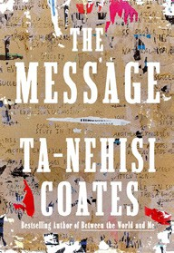

- Revenge of the Tipping Point
Malcolm Gladwell, Little, Brown and Company, $32
- Cher: The Memoir, Part One (The Cher Memoir #1)
Cher, Dey Street Books, $36
- The Demon of Unrest


Erik Larson, Crown, $35
- What I Ate in One Year
Stanley Tucci, Gallery Books, $35
- Nexus
Yuval Noah Harari, Random House, $35
- Patriot: A Memoir
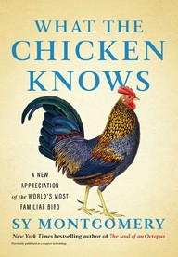

Alexei Navalny, Knopf, $35
- Half Baked Harvest Quick & Cozy
Tieghan Gerard, Clarkson Potter, $32.99
- The Creative Act: A Way of Being
Rick Rubin, Penguin Press, $32
- What the Chicken Knows


Sy Montgomery, Atria Books, $22.99
- Vanishing Treasures
Katherine Rundell, Doubleday, $26
- Framed
John Grisham, Jim McCloskey, Doubleday, $30
- Heartbreak Is the National Anthem: How Taylor Swift Reinvented Pop Music

Rob Sheffield, Dey Street Books, $27.99
December 4, 2024
For the week ending December 1, 2024 based on sales in hundreds of independent bookstores nationwide.
NONFICTION

RANK | PAPERBACK

  - The Backyard Bird Chronicles


Amy Tan, Knopf, $35
  - Braiding Sweetgrass
Robin Wall Kimmerer, Milkweed Editions, $20
  - The Art Thief
Michael Finkel, Vintage, $18
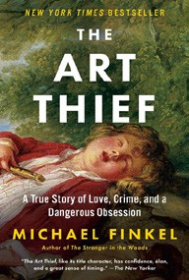

  - On Tyranny: Twenty Lessons from the Twentieth Century
Timothy Snyder, Crown, $12
  - Say Nothing: A True Story of Murder and Memory in Northern Ireland
Patrick Radden Keefe, Vintage, $20
  - Democracy Awakening


Heather Cox Richardson, Penguin, $18
  - Greenlights
Matthew McConaughey, Crown, $20
  - All About Love: New Visions
bell hooks, Morrow, $16.99
  - The 2025 Old Farmer’s Almanac


Old Farmer’s Almanac, $10.95
  - The Hundred Years’ War on Palestine
Rashid Khalidi, Metropolitan Books, $19.99
  - The Body Keeps the Score
Bessel van der Kolk, M.D., Penguin, $19
  - The Field Guide to Dumb Birds of North America
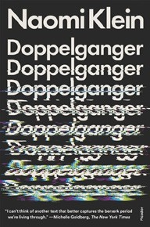

Matt Kracht, Chronicle, $15.95
  - Killers of the Flower Moon
David Grann, Vintage, $18
  - Crying in H Mart: A Memoir
Michelle Zauner, Vintage, $17
  - Doppelganger: A Trip into the Mirror World
Naomi Klein, Picador, $20

Debut
On the Rise Indies Introduce

