RANK | EARLY & MIDDLE GRADE
- Impossible Creatures
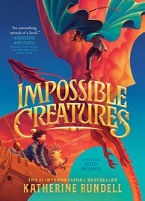



Katherine Rundell, Ashley Mackenzie (Illus.), Knopf Books for Young Readers, $19.99
- The Bletchley Riddle
Ruta Sepetys, Steve Sheinkin, Viking Books for Young Readers, $18.99
- The Squad: A Graphic Novel
Christina Soontornvat, Joanna Cacao (Illus.), Graphix, $12.99
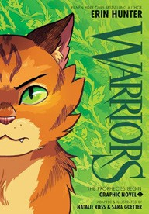

- The Millicent Quibb School of Etiquette for Young Ladies of Mad Science
Kate McKinnon, Little, Brown Books for Young Readers, $17.99
- Warriors Graphic Novel: The Prophecies Begin #1
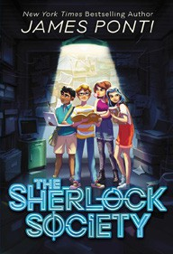

Erin Hunter, Natalie Riess (Illus.), Sara Goetter (Illus.), HarperAlley, $15.99
- The Sherlock Society
James Ponti, Aladdin, $18.99
- The Eyes and the Impossible
Dave Eggers, Shawn Harris (Illus.), Knopf Books for Young Readers, $19.99
- The New Girl: A Graphic Novel


Cassandra Calin, Graphix, $12.99
- The Best Christmas Pageant Ever
Barbara Robinson, HarperCollins, $9.99
- Super Duper Extra Deluxe Essential Handbook (Pokémon)
Scholastic, $16.99
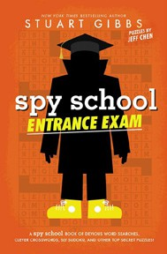

- The Last Dragon on Mars
Scott Reintgen, Aladdin, $18.99
- Let It Glow
Marissa Meyer, Joanne Levy, Feiwel & Friends, $9.99
- The Christmas Pig
J. K. Rowling, Jim Field (Illus.), Scholastic, $14.99
- Spy School Entrance Exam
Stuart Gibbs, Jeff Chen, Simon & Schuster Books for Young Readers, $10.99
- Smile: A Graphic Novel

Raina Telgemeier, Graphix, $12.99
Debut
Indies Introduce
December 4, 2024
For the week ending December 1, 2024 based on sales in hundreds of independent bookstores nationwide.
CHILDREN’S

RANK | YOUNG ADULT
  - Nothing Like the Movies
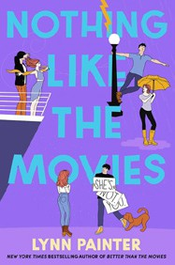

Lynn Painter, Simon & Schuster Books for Young Readers, $19.99
  - Powerless
Lauren Roberts, Simon & Schuster Books for Young Readers, $19.99
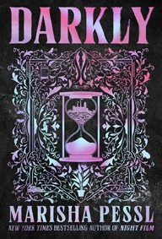
  - A Study in Drowning (Collector’s Deluxe Limited Edition)
Ava Reid, HarperCollins, $21.99
  - Darkly
Marisha Pessl, Delacorte Press, $19.99
  - Not for the Faint of Heart
Lex Croucher, Wednesday Books, $20
  - Better Than the Movies
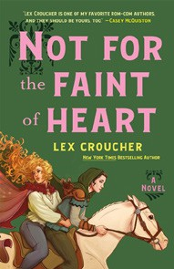

Lynn Painter, Simon & Schuster Books for Young Readers, $12.99
  - Heir
Sabaa Tahir, G.P. Putnam’s Sons Books for Young Readers, $21.99
  - If He Had Been with Me
Laura Nowlin, Sourcebooks Fire, $10.99
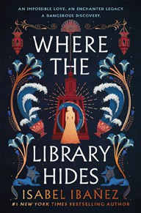

  - The Reappearance of Rachel Price
Holly Jackson, Delacorte Press, $20.99
  - Where the Library Hides
Isabel Ibañez, Wednesday Books, $20
  - Firekeeper’s Daughter
Angeline Boulley, Square Fish, $14.99
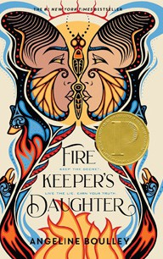

  - Reckless
Lauren Roberts, Simon & Schuster Books for Young Readers, $21.99
  - Pride and Prejudice
Jane Austen, Anna Bond (Illus.), Puffin Books, $17
  - The Outsiders
S. E. Hinton, Viking Books for Young Readers, $14.99
  - Divine Rivals
Rebecca Ross, Wednesday Books, $18.99

OTHER CHILDREN’S INDIE FAVORITES
AGES 8 TO 12 TEEN READERS
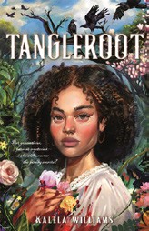

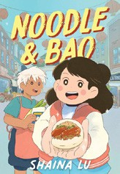

Noodle & Bao
Shaina Lu, Quill Tree Books, $24.99, Hardcover; $15.99, Paperback “Momo’s town is becoming more expensive and edging out small businesses like Noodle and Bao’s beloved restaurant. This book is an incredibly helpful tool for helping young people understanding gentrification and its impact — and it’s just a great story.”
—Milo Michels, University Book Store, Seattle, WA
Tangleroot
Kalela Williams, Feiwel & Friends, $19.99

“Sometimes your family history is as tangled as the vines on the ground. When Noni is forced to make a new home in the ‘Big House’ built by an enslaved ancestor, she may discover truths about herself and her family that none could have imagined.”
—Sally Sue Lavigne, The Storybook Shoppe, Bluffton, SC

