RANK | HARDCOVER

- James




Percival Everett, Doubleday, $28
- Intermezzo
Sally Rooney, Farrar, Straus and Giroux, $29
- The City and Its Uncertain Walls
Haruki Murakami, Knopf, $35
- Small Things Like These
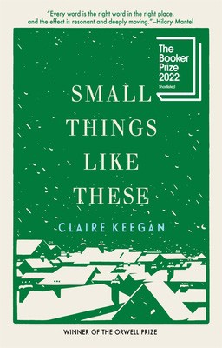

Claire Keegan, Grove Press, $20
- The God of the Woods
Liz Moore, Riverhead Books, $30
- The Grey Wolf
Louise Penny, Minotaur Books, $30
- The Women
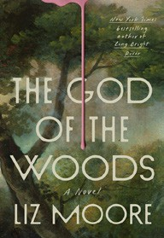

Kristin Hannah, St. Martin’s Press, $30
- Playground
Richard Powers, W. W. Norton & Company, $29.99
- Tell Me Everything
Elizabeth Strout, Random House, $30
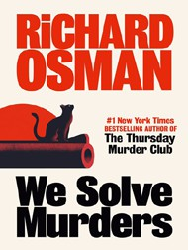
- All Fours
Miranda July, Riverhead Books, $29
- Somewhere Beyond the Sea
TJ Klune, Tor Books, $28.99
- The Wedding People
Alison Espach, Henry Holt and Co., $28.99
- The Life Impossible
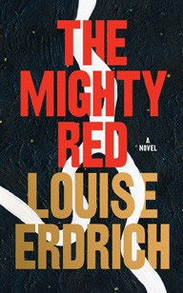

Matt Haig, Viking, $30
- We Solve Murders
Richard Osman, Pamela Dorman Books, $30
- The Mighty Red
Louise Erdrich, Harper, $32
December 4, 2024
For the week ending December 1, 2024 based on sales in hundreds of independent bookstores nationwide.
FICTION

RANK | PAPERBACK
  - Demon Copperhead
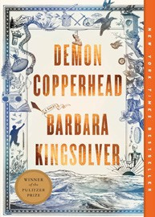

Barbara Kingsolver, Harper Perennial, $21.99
  - Orbital
Samantha Harvey, Grove Press, $17
  - The Frozen River
Ariel Lawhon, Vintage, $18
  - North Woods


Daniel Mason, Random House Trade Paperbacks,
$18
  - Fourth Wing
Rebecca Yarros, Entangled: Red Tower Books, $20.99
  - The Berry Pickers
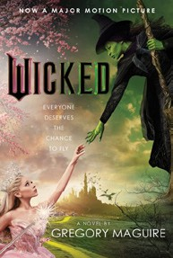
Amanda Peters, Catapult, $17.95
  - Wicked
Gregory Maguire, William Morrow Paperbacks, $19.99
  - A Court of Thorns and Roses
Sarah J. Maas, Bloomsbury Publishing, $19
  - Hello Beautiful
Ann Napolitano, Dial Press Trade Paperback, $18.99


  - Tomorrow, and Tomorrow, and Tomorrow
Gabrielle Zevin, Vintage, $19
  - The Vegetarian
Han Kang, Hogarth, $17
  - The Christmas Tree Farm
Laurie Gilmore, One More Chapter, $18.99
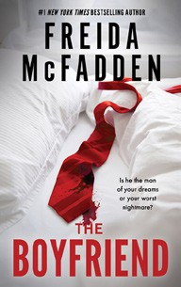

  - The Boyfriend
Freida McFadden, Poisoned Pen Press, $17.99
  - The Best American Short Stories 2024
Lauren Groff, Heidi Pitlor (Eds.), Mariner Books, $19.99
  - The Housemaid
Freida McFadden, Grand Central, $12.99

Debut
On the Rise Indies Introduce

