RANK | FICTION
- Demon Copperhead
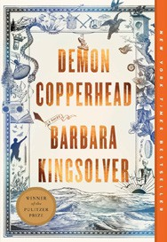



Barbara Kingsolver, Harper Perennial, $21.99
- Fourth Wing
Rebecca Yarros, Entangled: Red Tower Books, $20.99
- North Woods
Daniel Mason, Random House Trade Paperbacks, $18
- The Boyfriend
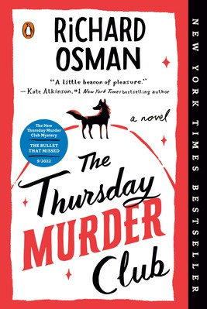

Freida McFadden, Poisoned Pen Press, $17.99
- A Court of Thorns and Roses
Sarah J. Maas, Bloomsbury Publishing, $19
- The Pumpkin Spice Café
Laurie Gilmore, One More Chapter, $18.99
- The Housemaid
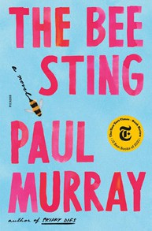

Freida McFadden, Grand Central, $12.99
- Tomorrow, and Tomorrow, and Tomorrow
Gabrielle Zevin, Vintage, $19
- The Midnight Library
Matt Haig, Penguin, $18
- The Thursday Murder Club
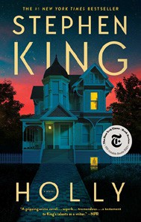

Richard Osman, Penguin, $18
- The Bee Sting
Paul Murray, Picador, $20
- It Ends with Us
Colleen Hoover, Atria, $16.99
- Never Whistle at Night: An Indigenous Dark Fiction Anthology


Shane Hawk (Ed.), Theodore C. Van Alst Jr. (Ed.), Vintage, $17
- Holly
Stephen King, Scribner, $19.99
- The Vegetarian
Han Kang, Hogarth, $17

OTHER PAPERBACK INDIE FAVORITES
Chenneville: A Novel of Murder, Loss, and Vengeance
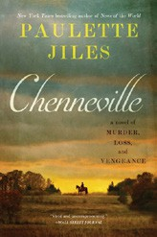

Paulette Jiles, William Morrow Paperbacks, $18.99 “Paulette Jiles has done it again. John Chenneville’s travails
through the post-Civil War US are written in a way that is thoughtful, profound, and fluid like poetry. Even if you’re not familiar with Jiles, once you read it, you’ll want more.”
—Vicki Honeyman, Literati Bookstore, Ann Arbor, MI
October 23, 2024
For the week ending October 20, 2024 based on sales in hundreds of independent bookstores nationwide.
PAPERBACK

RANK | NONFICTION
  - The Art Thief: A True Story of Love, Crime, and a Dangerous Obsession Michael Finkel, Vintage, $18
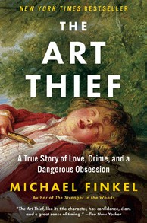

  - The Backyard Bird Chronicles
Amy Tan, Knopf, $35
  - Braiding Sweetgrass
Robin Wall Kimmerer, Milkweed Editions, $20


  - The Hundred Years’ War on Palestine
Rashid Khalidi, Metropolitan Books, $19.99
  - The Body Keeps the Score
Bessel van der Kolk, M.D., Penguin, $19
  - All About Love: New Visions
bell hooks, Morrow, $16.99


  - The Truths We Hold
Kamala Harris, Penguin, $20
  - The 2025 Old Farmer’s Almanac
Old Farmer’s Almanac, $10.95
  - Doppelganger: A Trip into the Mirror World
Naomi Klein, Picador, $20


  - Hillbilly Elegy
J. D. Vance, Harper, $18.99
  - Four Thousand Weeks
Oliver Burkeman, Picador, $19
  - Astor: The Rise and Fall of an American Fortune
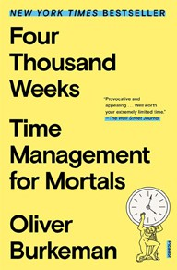

Anderson Cooper, Katherine Howe, Harper, $19.99
  - Witchcraft: A History in Thirteen Trials
Marion Gibson, Scribner, $18.99
  - Crying in H Mart: A Memoir
Michelle Zauner, Vintage, $17
  - Talking to Strangers: What We Should Know about the People We Don’t Know Malcolm Gladwell, Back Bay, $21.99
Debut
On the Rise

MASS MARKET Indies Introduce
- 1984 George Orwell, Signet, $9.99
- Mistborn: The Final Empire Brandon Sanderson, Tor, $10.99
- The Exchange John Grisham, Vintage, $10.99
- The Way of Kings Brandon Sanderson, Tor, $12.99
- The House Across the Lake Riley Sager, Dutton, $10.99
- Code Red Vince Flynn, Kyle Mills, Pocket, $10.99
- 23 1/2 Lies James Patterson, Grand Central, $10.99
- The Long Walk Stephen King, Pocket, $11.99
- The Shining Stephen King, Vintage, $9.99
- Invisible Girl Lisa Jewell, Pocket, $10.99

