RANK | FICTION
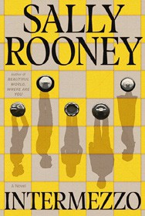


- Intermezzo
Sally Rooney, Farrar, Straus and Giroux, $29
- Tell Me Everything
Elizabeth Strout, Random House, $30
- Playground
Richard Powers, W. W. Norton & Company, $29.99
- Somewhere Beyond the Sea
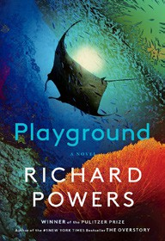

TJ Klune, Tor Books, $28.99
- The Life Impossible
Matt Haig, Viking, $30
- We Solve Murders
Richard Osman, Pamela Dorman Books, $30
- James
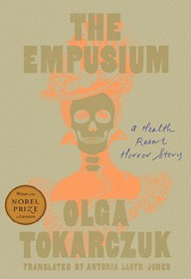

Percival Everett, Doubleday, $28
- The God of the Woods
Liz Moore, Riverhead Books, $30
- The Women
Kristin Hannah, St. Martin’s Press, $30
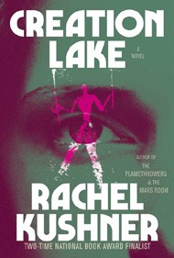
- The Empusium
Olga Tokarczuk, Antonia Lloyd-Jones (Transl.), Riverhead Books, $30
- Here One Moment
Liane Moriarty, Crown, $30
- All Fours
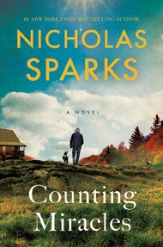
Miranda July, Riverhead Books, $29
- Creation Lake
Rachel Kushner, Scribner, $29.99
- Counting Miracles
Nicholas Sparks, Random House, $30
- The Wedding People
Alison Espach, Henry Holt and Co., $28.99
October 2, 2024
For the week ending September 29, 2024 based on sales in hundreds of independent bookstores nationwide.
HARDCOVER

RANK | NONFICTION
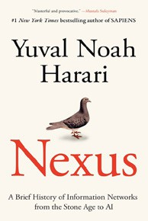
  - Nexus: A Brief History of Information Networks from the Stone Age to AI Yuval Noah Harari, Random House, $35
  - The Small and the Mighty: Twelve Unsung Americans Who Changed the
Course of History, from the Founding to the Civil Rights Movement
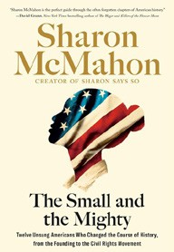
Sharon McMahon, Thesis, $32
  - Something Lost, Something Gained
Hillary Rodham Clinton, Simon & Schuster, $29.99
  - On Freedom
Timothy Snyder, Crown, $32
  - The Barn: The Secret History of a Murder in Mississippi
Wright Thompson, Penguin Press, $35
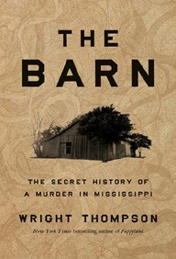

  - The Demon of Unrest
Erik Larson, Crown, $35
  - The Anxious Generation
Jonathan Haidt, Penguin Press, $30
  - The Creative Act: A Way of Being
Rick Rubin, Penguin Press, $32
  - Does This Taste Funny?
Stephen Colbert, Evie McGee Colbert, Celadon Books, $35


  - Lovely One: A Memoir
Ketanji Brown Jackson, Random House, $35
  - The Third Gilmore Girl: A Memoir
Kelly Bishop, Gallery Books, $28.99
  - Atomic Habits
James Clear, Avery, $27
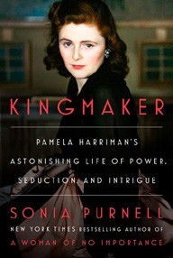

  - Want: Sexual Fantasies by Anonymous
Gillian Anderson, Harry N. Abrams, $28
  - What If We Get It Right?
Ayana Elizabeth Johnson, One World, $34
  - The Wager
David Grann, Doubleday, $30
  - Kingmaker: Pamela Harriman’s Astonishing Life of Power, Seduction, and Intrigue

Sonia Purnell, Viking, $35

OTHER HARDCOVER INDIE FAVORITES
Debut
On the Rise

Indies Introduce

A Sunny Place for Shady People: Stories


Mariana Enríquez, Megan McDowell (Transl.), Hogarth, $28 “Mariana Enríquez is willing and able to explore the darkness sim- mering in both Buenos Aires and the Argentinean countryside. Be
prepared for her mesmerizing storytelling and otherworldly horrors.”
—Elizabeth Ahlquist, Blue Cypress Books, New Orleans, LA
The Wildes: A Novel in Five Acts
Louis Bayard, Algonquin Books, $29


“Bayard transports us to the British countryside, an Italian villa, the trenches of France, and back to London. Told in the language of the late 19th & early 20th centuries, The Wildes involves the entire Wilde family and the scandalous drama that ensues.”
—Mindy Ostrow, The River’s End Bookstore, Oswego, NY

