RANK | HARDCOVER

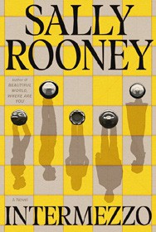


- Intermezzo
Sally Rooney, Farrar, Straus and Giroux, $29
- Tell Me Everything
Elizabeth Strout, Random House, $30
- Playground
Richard Powers, W. W. Norton & Company, $29.99
- Somewhere Beyond the Sea
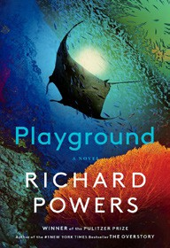

TJ Klune, Tor Books, $28.99
- The Life Impossible
Matt Haig, Viking, $30
- We Solve Murders
Richard Osman, Pamela Dorman Books, $30
- James
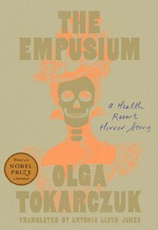

Percival Everett, Doubleday, $28
- The God of the Woods
Liz Moore, Riverhead Books, $30
- The Women
Kristin Hannah, St. Martin’s Press, $30
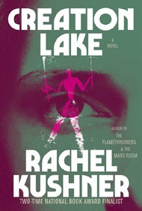
- The Empusium
Olga Tokarczuk, Antonia Lloyd-Jones (Transl.), Riverhead Books, $30
- Here One Moment
Liane Moriarty, Crown, $30
- All Fours
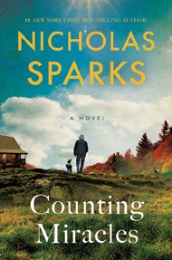
Miranda July, Riverhead Books, $29
- Creation Lake
Rachel Kushner, Scribner, $29.99
- Counting Miracles
Nicholas Sparks, Random House, $30
- The Wedding People
Alison Espach, Henry Holt and Co., $28.99
October 2, 2024
For the week ending September 29, 2024 based on sales in hundreds of independent bookstores nationwide.
FICTION

RANK | PAPERBACK
  - Demon Copperhead
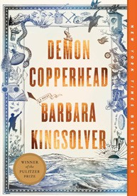

Barbara Kingsolver, Harper Perennial, $21.99
  - Fourth Wing
Rebecca Yarros, Entangled: Red Tower Books, $20.99
  - A Court of Thorns and Roses
Sarah J. Maas, Bloomsbury Publishing, $19
  - Tomorrow, and Tomorrow, and Tomorrow
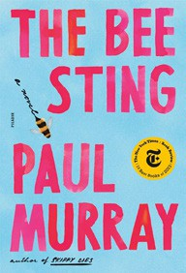

Gabrielle Zevin, Vintage, $19
  - The Bee Sting
Paul Murray, Picador, $20
  - The Thursday Murder Club
Richard Osman, Penguin, $18
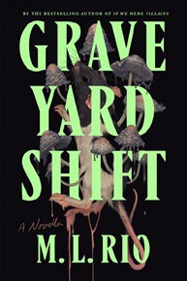
  - It Ends with Us
Colleen Hoover, Atria, $16.99
  - Graveyard Shift: A Novella
M. L. Rio, Flatiron Books, $16.99
  - The Midnight Library
Matt Haig, Penguin, $18
  - The Housemaid


Freida McFadden, Grand Central, $12.99
  - The Best Short Stories 2024: The O. Henry Prize Winners
Amor Towles (Ed.), Jenny Minton Quigley (Ed.), Vintage, $19
  - My Brilliant Friend
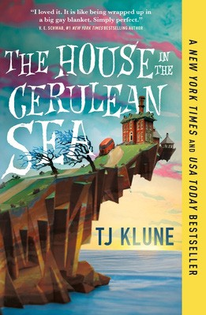

Elena Ferrante, Europa Editions, $17
  - Holly
Stephen King, Scribner, $19.99
  - The Fraud
Zadie Smith, Penguin, $19
  - The House in the Cerulean Sea
TJ Klune, Tor, $18.99

Debut
On the Rise Indies Introduce

