RANK | FICTION
- Demon Copperhead
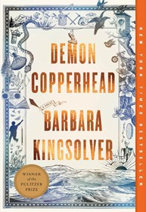



Barbara Kingsolver, Harper Perennial, $21.99
- A Court of Thorns and Roses
Sarah J. Maas, Bloomsbury Publishing, $19
- Tomorrow, and Tomorrow, and Tomorrow
Gabrielle Zevin, Vintage, $19
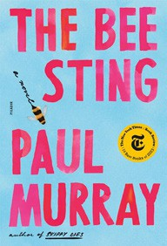
- It Ends with Us
Colleen Hoover, Atria, $16.99
- The Bee Sting
Paul Murray, Picador, $20
- The Housemaid
Freida McFadden, Grand Central, $12.99
- Daydream


Hannah Grace, Atria, $19.99
- My Brilliant Friend
Elena Ferrante, Europa Editions, $17
- Just for the Summer
Abby Jimenez, Forever, $17.99
- The Midnight Library
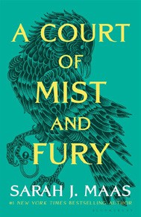

Matt Haig, Penguin, $18
- The Pairing
Casey McQuiston, St. Martin’s Griffin, $20
- A Court of Mist and Fury
Sarah J. Maas, Bloomsbury Publishing, $19
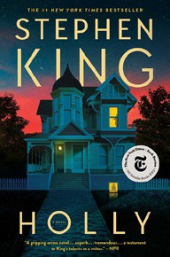
- Holly
Stephen King, Scribner, $19.99
- It Starts with Us
Colleen Hoover, Atria, $17.99
- The Seven Husbands of Evelyn Hugo
Taylor Jenkins Reid, Atria, $17

OTHER PAPERBACK INDIE FAVORITES
Best Copy Available: A True Crime Memoir
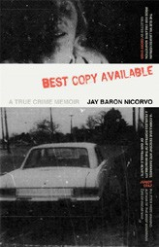

Jay Baron Nicorvo, University of Georgia Press, $28.95
“Do not shy away from this memoir. It’s a hard read but it’s so worth it. Nicorvo is masterful in his ability to share the trauma of his child- hood. Part memoir, part true crime, completely unforgettable!”
—Julie Slavinsky, Warwick’s, La Jolla, CA
September 11, 2024
For the week ending September 8, 2024 based on sales in hundreds of independent bookstores nationwide.
PAPERBACK

RANK | NONFICTION
  - The Backyard Bird Chronicles


Amy Tan, Knopf, $35
  - The Art Thief
Michael Finkel, Vintage, $18
  - The Truths We Hold
Kamala Harris, Penguin, $20
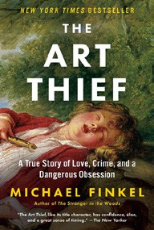

  - Braiding Sweetgrass
Robin Wall Kimmerer, Milkweed Editions, $20
  - All About Love: New Visions
bell hooks, Morrow, $16.99
  - The Body Keeps the Score
Bessel van der Kolk, M.D., Penguin, $19


  - Going Infinite
Michael Lewis, W. W. Norton & Company, $19.99
  - The Hundred Years’ War on Palestine
Rashid Khalidi, Metropolitan Books, $19.99
  - The 2025 Old Farmer’s Almanac
Old Farmer’s Almanac, $10.95
  - Hillbilly Elegy


J. D. Vance, Harper, $18.99
  - Crying in H Mart: A Memoir
Michelle Zauner, Vintage, $17
  - Everything I Know About Love: A Memoir
Dolly Alderton, Harper Perennial, $18.99
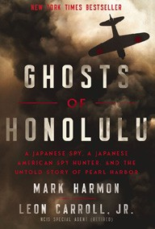
  - Killers of the Flower Moon
David Grann, Vintage, $18
  - Talking to Strangers
Malcolm Gladwell, Back Bay, $21.99
  - Ghosts of Honolulu: A Japanese Spy, a Japanese American Spy Hunter, and the Untold Story of Pearl Harbor
Mark Harmon, Leon Carroll, Jr., Harper Select, $19.99

Debut
On the Rise

MASS MARKET Indies Introduce
- 1984 George Orwell, Signet, $9.99
- The Way of Kings Brandon Sanderson, Tor, $12.99
- Mistborn: The Final Empire Brandon Sanderson, Tor, $10.99
- Dune Frank Herbert, Ace, $10.99
- The Secret Lee Child, Andrew Child, Dell, $10.99
- Invisible Girl Lisa Jewell, Pocket, $10.99

- Animal Farm George Orwell, Signet, $9.99
- Camino Island John Grisham, Vintage, $10.99
- A Game of Thrones George R. R. Martin, Bantam, $9.99
- The House of Wolves James Patterson, Mike Lupica, Grand Central, $10.99

