RANK | HARDCOVER

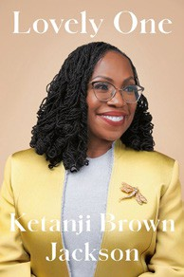


- Lovely One: A Memoir
Ketanji Brown Jackson, Random House, $35
- The Demon of Unrest
Erik Larson, Crown, $35
- The Anxious Generation
Jonathan Haidt, Penguin Press, $30
- The Creative Act: A Way of Being


Rick Rubin, Penguin Press, $32
- The Art of Power
Nancy Pelosi, Simon & Schuster, $30
- Atomic Habits
James Clear, Avery, $27
- The Bookshop
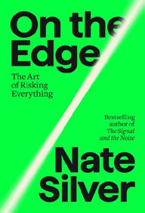

Evan Friss, Viking, $30
- The Wager
David Grann, Doubleday, $30
- On the Edge: The Art of Risking Everything
Nate Silver, Penguin Press, $35
- That Librarian


Amanda Jones, Bloomsbury Publishing, $29.99
- The Little Frog’s Guide to Self-Care
Maybell Eequay, Summersdale, $11.99
- An Unfinished Love Story
Doris Kearns Goodwin, Simon & Schuster, $35

- I Heard There Was a Secret Chord: Music as Medicine
Daniel J. Levitin, W. W. Norton & Company, $32.50
- Big Vegan Flavor: Techniques and 150 Recipes to Master Vegan Cooking Nisha Vora, Avery, $45
- Autocracy, Inc.: The Dictators Who Want to Run the World
Anne Applebaum, Doubleday, $27
September 11, 2024
For the week ending September 8, 2024 based on sales in hundreds of independent bookstores nationwide.
NONFICTION

RANK | PAPERBACK

  - The Backyard Bird Chronicles


Amy Tan, Knopf, $35
  - The Art Thief
Michael Finkel, Vintage, $18
  - The Truths We Hold
Kamala Harris, Penguin, $20
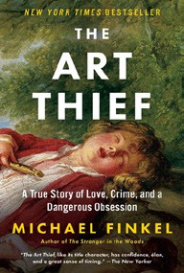

  - Braiding Sweetgrass
Robin Wall Kimmerer, Milkweed Editions, $20
  - All About Love: New Visions
bell hooks, Morrow, $16.99
  - The Body Keeps the Score
Bessel van der Kolk, M.D., Penguin, $19


  - Going Infinite
Michael Lewis, W. W. Norton & Company, $19.99
  - The Hundred Years’ War on Palestine
Rashid Khalidi, Metropolitan Books, $19.99
  - The 2025 Old Farmer’s Almanac
Old Farmer’s Almanac, $10.95
  - Hillbilly Elegy


J. D. Vance, Harper, $18.99
  - Crying in H Mart: A Memoir
Michelle Zauner, Vintage, $17
  - Everything I Know About Love: A Memoir
Dolly Alderton, Harper Perennial, $18.99
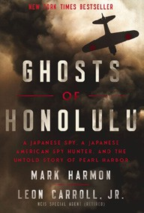
  - Killers of the Flower Moon
David Grann, Vintage, $18
  - Talking to Strangers
Malcolm Gladwell, Back Bay, $21.99
  - Ghosts of Honolulu: A Japanese Spy, a Japanese American Spy Hunter, and the Untold Story of Pearl Harbor
Mark Harmon, Leon Carroll, Jr., Harper Select, $19.99

Debut
On the Rise Indies Introduce

