RANK | EARLY & MIDDLE GRADE
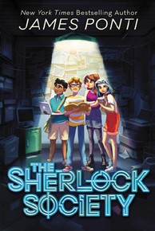


- The Sherlock Society
James Ponti, Aladdin, $18.99
- Warriors Graphic Novel: The Prophecies Begin #1
Erin Hunter, Natalie Riess (Illus.), Sara Goetter (Illus.), HarperAlley, $15.99
- Out of My Dreams
Sharon M. Draper, Atheneum/Caitlyn Dlouhy Books,
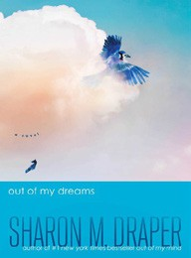

$18.99
- The New Girl: A Graphic Novel
Cassandra Calin, Graphix, $12.99
- Super Duper Extra Deluxe Essential Handbook (Pokémon)
Scholastic, $16.99
- The Swifts: A Gallery of Rogues
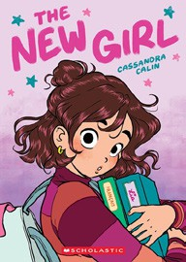

Beth Lincoln, Claire Powell (Illus.), Dutton Books for Young Readers, $17.99
- The Night Librarian: A Graphic Novel
Christopher Lincoln, Dial Books, $13.99
- The One and Only Family
Katherine Applegate, Harper, $19.99
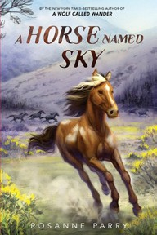

- Unico: Awakening (Volume 1): An Original Manga
Tezuka Osamu, Samuel Sattin, Gurihiru (Illus.), Graphix, $12.99
- A Horse Named Sky
Rosanne Parry, Kirbi Fagan (Illus.), Greenwillow Books,
$9.99
- Orris and Timble: The Beginning


Kate DiCamillo, Carmen Mok (Illus.), Candlewick,
$16.99
- Smile: A Graphic Novel
Raina Telgemeier, Graphix, $12.99
- The Eyes and the Impossible
Dave Eggers, Shawn Harris (Illus.), Knopf Books for Young Readers, $19.99
- Swim School: A Bluey Storybook
Penguin Young Readers, $5.99
- Charlotte’s Web

E. B. White, Harper, $10.99
Debut
Indies Introduce
September 11, 2024
For the week ending September 8, 2024 based on sales in hundreds of independent bookstores nationwide.
CHILDREN’S

RANK | YOUNG ADULT
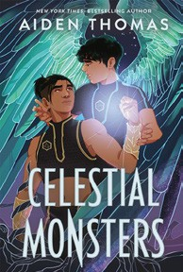
  - Celestial Monsters
Aiden Thomas, Feiwel & Friends, $19.99
  - Compound Fracture
Andrew Joseph White, Peachtree Teen, $19.99
  - Immortal Dark (Deluxe Limited Edition)
Tigest Girma, Little, Brown Books for Young Readers,
$19.99


  - Powerless
Lauren Roberts, Simon & Schuster Books for Young Readers, $19.99
  - If He Had Been with Me
Laura Nowlin, Sourcebooks Fire, $10.99
  - Reckless
Lauren Roberts, Simon & Schuster Books for Young Readers, $21.99
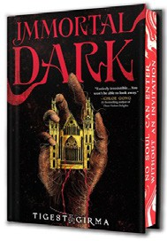

  - The Grandest Game
Jennifer Lynn Barnes, Little, Brown Books for Young Readers, $19.99
  - If Only I Had Told Her
Laura Nowlin, Sourcebooks Fire, $12.99
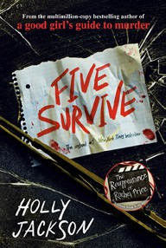

  - The Reappearance of Rachel Price
Holly Jackson, Delacorte Press, $20.99
  - Such Charming Liars
Karen M. McManus, Delacorte Press, $20.99
  - Divine Rivals
Rebecca Ross, Wednesday Books, $18.99


  - Better Than the Movies
Lynn Painter, Simon & Schuster Books for Young Readers, $12.99
  - Five Survive
Holly Jackson, Ember, $14.99
  - Pride and Prejudice
Jane Austen, Anna Bond (Illus.), Puffin Books, $17
  - The Outsiders
S. E. Hinton, Viking Books for Young Readers, $12.99

OTHER CHILDREN’S INDIE FAVORITES
AGES 8 TO 12 TEEN READERS
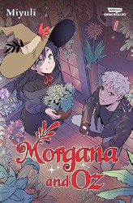

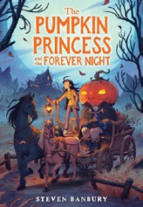

The Pumpkin Princess and the Forever Night
Steven Banbury, Little, Brown Books for Young Readers,


$17.99, Hardcover; $8.99, Paperback
“I was instantly delighted by The Pumpkin Princess and the Forever Night. Banbury does such a beautiful job creating a cozy-yet-lightly- spooky world. I felt transported to the Fall of my dreams. I can’t wait to make everyone I know read this book!”
—Nancy Eyre, Powell’s Books, Portland, OR
Morgana and Oz Volume One: A Graphic Novel
Miyuli, WEBTOON Unscrolled, $18.99
“I loved this book! The art is fantastic and cute. I adored the story line of Morgana and Oz; it seemed simple but I loved how it flushed into this complex world. A 10/10!”
—Kimmy Rocca, Your Brother’s Bookstore, Evansville, IN

