RANK | HARDCOVER




- The Life Impossible
Matt Haig, Viking, $30
- Creation Lake
Rachel Kushner, Scribner, $29.99
- The Women
Kristin Hannah, St. Martin’s Press, $30
- The God of the Woods


Liz Moore, Riverhead Books, $30
- James
Percival Everett, Doubleday, $28
- By Any Other Name
Jodi Picoult, Ballantine Books, $30

- The Wedding People
Alison Espach, Henry Holt and Co., $28.99
- Blue Sisters
Coco Mellors, Ballantine Books, $30
- All Fours
Miranda July, Riverhead Books, $29
- Death at the Sign of the Rook

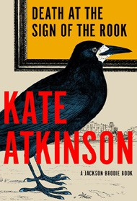

Kate Atkinson, Doubleday, $30
- All the Colors of the Dark
Chris Whitaker, Crown, $30
- The Games Gods Play (Deluxe Limited Edition)

Abigail Owen, Entangled: Red Tower Books, $32.99


- Colored Television

Danzy Senna, Riverhead Books, $29
- Sandwich
Catherine Newman, Harper, $26.99
- We’ll Prescribe You a Cat

Syou Ishida, E. Madison Shimoda (Transl.), Berkley,
$25
September 11, 2024
For the week ending September 8, 2024 based on sales in hundreds of independent bookstores nationwide.
FICTION

RANK | PAPERBACK
  - Demon Copperhead
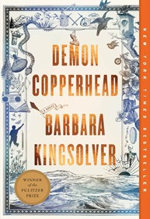

Barbara Kingsolver, Harper Perennial, $21.99
  - A Court of Thorns and Roses
Sarah J. Maas, Bloomsbury Publishing, $19
  - Tomorrow, and Tomorrow, and Tomorrow
Gabrielle Zevin, Vintage, $19
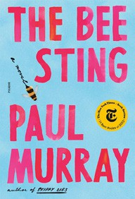
  - It Ends with Us
Colleen Hoover, Atria, $16.99
  - The Bee Sting
Paul Murray, Picador, $20
  - The Housemaid
Freida McFadden, Grand Central, $12.99
  - Daydream


Hannah Grace, Atria, $19.99
  - My Brilliant Friend
Elena Ferrante, Europa Editions, $17
  - Just for the Summer
Abby Jimenez, Forever, $17.99
  - The Midnight Library


Matt Haig, Penguin, $18
  - The Pairing
Casey McQuiston, St. Martin’s Griffin, $20
  - A Court of Mist and Fury
Sarah J. Maas, Bloomsbury Publishing, $19
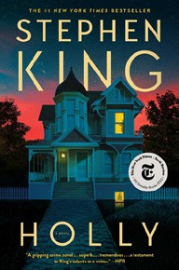
  - Holly
Stephen King, Scribner, $19.99
  - It Starts with Us
Colleen Hoover, Atria, $17.99
  - The Seven Husbands of Evelyn Hugo
Taylor Jenkins Reid, Atria, $17

Debut
On the Rise Indies Introduce

