RANK | FICTION
- Tomorrow, and Tomorrow, and Tomorrow
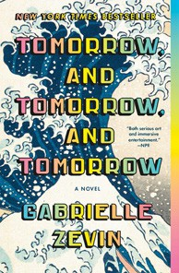



Gabrielle Zevin, Vintage, $19
- A Court of Thorns and Roses
Sarah J. Maas, Bloomsbury Publishing, $19
- Just for the Summer
Abby Jimenez, Forever, $17.99
- Happy Place


Emily Henry, Berkley, $19
- The Housemaid
Freida McFadden, Grand Central, $12.99
- Not in Love
Ali Hazelwood, Berkley, $19
- A Court of Mist and Fury
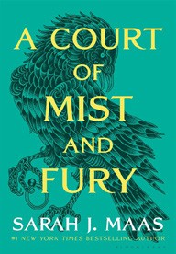

Sarah J. Maas, Bloomsbury Publishing, $19
- The Housemaid Is Watching
Freida McFadden, Poisoned Pen Press, $17.99
- The Seven Husbands of Evelyn Hugo
Taylor Jenkins Reid, Atria, $17
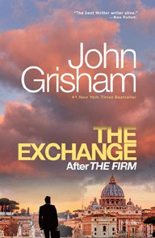
- It Ends with Us
Colleen Hoover, Atria, $16.99
- The Exchange
John Grisham, Vintage, $18
- Lady Tan’s Circle of Women
Lisa See, Scribner, $18.99
- The Midnight Library
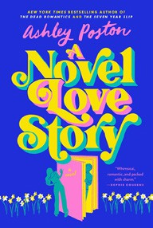

Matt Haig, Penguin, $18
- Throne of Glass
Sarah J. Maas, Bloomsbury Publishing, $19
- A Novel Love Story
Ashley Poston, Berkley, $19

OTHER PAPERBACK INDIE FAVORITES
How to Say Babylon: A Memoir
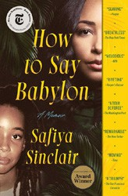

Safiya Sinclair, Simon & Schuster, $18.99
“This extraordinary memoir explores self-actualization at the crossroads of womanhood and Black liberation. Sinclair’s poetic brilliance brought grace to even her most excruciating experiences. I am in awe of her compassion and transcendence.”
—Evisa Gallman, Uncle Bobbie’s Coffee & Books, Philadelphia, PA
July 24, 2024
For the week ending July 21, 2024 based on sales in hundreds of independent bookstores nationwide.
PAPERBACK

RANK | NONFICTION
  - The Art Thief: A True Story of Love, Crime, and a Dangerous Obsession Michael Finkel, Vintage, $18
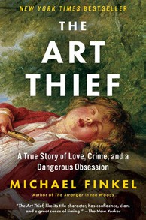

  - Braiding Sweetgrass
Robin Wall Kimmerer, Milkweed Editions, $20
  - The Hundred Years’ War on Palestine
Rashid Khalidi, Metropolitan Books, $19.99


  - The Body Keeps the Score
Bessel van der Kolk M.D., Penguin, $19
  - All About Love: New Visions
bell hooks, Morrow, $16.99
  - Hillbilly Elegy
J. D. Vance, Harper, $17.99


  - Everything I Know About Love: A Memoir
Dolly Alderton, Harper Perennial, $18.99
  - Killers of the Flower Moon
David Grann, Vintage, $18
  - Friends, Lovers, and the Big Terrible Thing
Matthew Perry, Flatiron Books, $18.99


  - Crying in H Mart: A Memoir
Michelle Zauner, Vintage, $17
  - World Travel: An Irreverent Guide
Anthony Bourdain, Laurie Woolever, Ecco, $22
  - What an Owl Knows
Jennifer Ackerman, Penguin, $19


  - Poverty, by America
Matthew Desmond, Crown, $20
  - A Fever in the Heartland: The Ku Klux Klan’s Plot to Take Over America, and the Woman Who Stopped Them
Timothy Egan, Penguin, $18
  - The Four Agreements
Don Miguel Ruiz, Amber-Allen, $12.95
Debut
On the Rise

MASS MARKET Indies Introduce
- 1984 George Orwell, Signet, $9.99
- The Secret Lee Child, Andrew Child, Dell, $10.99
- Dune Frank Herbert, Ace, $10.99
- Fairy Tale Stephen King, Pocket, $11.99
- Animal Farm George Orwell, Signet, $9.99
- The Way of Kings Brandon Sanderson, Tor, $11.99
- The Five-Star Weekend Elin Hilderbrand, Little, Brown and Company, $10.99
- Tom Clancy Weapons Grade Don Bentley, Berkley, $10.99
- Fire & Blood George R. R. Martin, Bantam, $9.99
- The Paris Apartment Lucy Foley, William Morrow, $10.99

