RANK | FICTION
- The Women




Kristin Hannah, St. Martin’s Press, $30
- The God of the Woods
Liz Moore, Riverhead Books, $30
- James
Percival Everett, Doubleday, $28
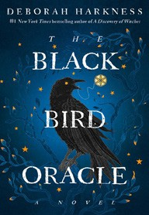
- The Black Bird Oracle
Deborah Harkness, Ballantine Books, $32
- Sandwich
Catherine Newman, Harper, $26.99
- The Bright Sword
Lev Grossman, Viking, $35
- All Fours
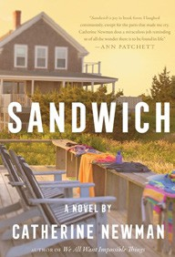

Miranda July, Riverhead Books, $29
- Long Island Compromise
Taffy Brodesser-Akner, Random House, $30
- Funny Story
Emily Henry, Berkley, $29
- All the Colors of the Dark
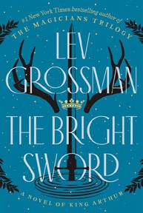

Chris Whitaker, Crown, $30
- The Ministry of Time
Kaliane Bradley, Avid Reader Press/Simon & Schuster,
$28.99
- A Death in Cornwall
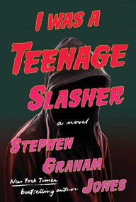
Daniel Silva, Harper, $32
- The Midnight Feast
Lucy Foley, William Morrow, $30
- Swan Song
Elin Hilderbrand, Little, Brown and Company, $30
- I Was A Teenage Slasher
Stephen Graham Jones, S&S/Saga Press, $29.99
July 24, 2024
For the week ending July 21, 2024 based on sales in hundreds of independent bookstores nationwide.
HARDCOVER

RANK | NONFICTION
  - The Demon of Unrest: A Saga of Hubris, Heartbreak, and Heroism at the Dawn of the Civil War


Erik Larson, Crown, $35
  - The Anxious Generation
Jonathan Haidt, Penguin Press, $30
  - The Creative Act: A Way of Being


Rick Rubin, Penguin Press, $32
  - The Wager
David Grann, Doubleday, $30
  - On Call: A Doctor’s Journey in Public Service
Anthony Fauci, M.D., Viking, $36
  - Atomic Habits


James Clear, Avery, $27
  - An Unfinished Love Story
Doris Kearns Goodwin, Simon & Schuster, $35
  - The Friday Afternoon Club: A Family Memoir
Griffin Dunne, Penguin Press, $30
  - The Light Eaters
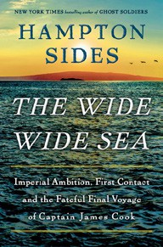

Zoë Schlanger, Harper, $29.99
  - A Walk in the Park
Kevin Fedarko, Scribner, $32.50
  - Outlive: The Science and Art of Longevity
Peter Attia M.D., Bill Gifford, Harmony, $32
  - The Wide Wide Sea


Hampton Sides, Doubleday, $35
  - In My Time of Dying
Sebastian Junger, Simon & Schuster, $27.99
  - True Gretch
Gretchen Whitmer, Simon & Schuster, $26.99
  - Democracy or Else: How to Save America in 10 Easy Steps
Jon Favreau, Jon Lovett, Tommy Vietor, Zando-Crooked Media Reads, $28
Debut
On the Rise

OTHER HARDCOVER INDIE FAVORITES
Indies Introduce

The Heart in Winter: A Novel


Kevin Barry, Doubleday, $28
“I found this story of two young lovers on the run in 1890s Montana to have the grit of a Cormac McCarthy novel, and the adventure and peril found in Cold Mountain. I expect this stunning novel to stay with me for a long time.”
—Linda Grana, Reasonable Books, Lafayette, CA
State of Paradise: A Novel
Laura van den Berg, Farrar, Straus and Giroux, $27


“Unnerving, odd, sometimes spooky, sometimes very funny. Here is a world of warped reality — by grief, by pandemic, by Major Weather Events, by technology, sometimes even by our own minds. This is one of Laura van den Berg’s best.”
—Santiago Nocera, Greedy Reads, Baltimore, MD

