RANK | HARDCOVER

- The Women




Kristin Hannah, St. Martin’s Press, $30
- The God of the Woods
Liz Moore, Riverhead Books, $30
- James
Percival Everett, Doubleday, $28
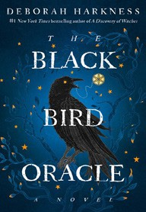
- The Black Bird Oracle
Deborah Harkness, Ballantine Books, $32
- Sandwich
Catherine Newman, Harper, $26.99
- The Bright Sword
Lev Grossman, Viking, $35
- All Fours
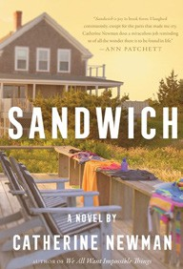

Miranda July, Riverhead Books, $29
- Long Island Compromise
Taffy Brodesser-Akner, Random House, $30
- Funny Story
Emily Henry, Berkley, $29
- All the Colors of the Dark
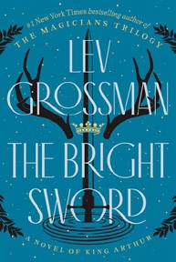

Chris Whitaker, Crown, $30
- The Ministry of Time
Kaliane Bradley, Avid Reader Press/Simon & Schuster,
$28.99
- A Death in Cornwall
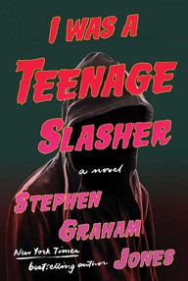
Daniel Silva, Harper, $32
- The Midnight Feast
Lucy Foley, William Morrow, $30
- Swan Song
Elin Hilderbrand, Little, Brown and Company, $30
- I Was A Teenage Slasher
Stephen Graham Jones, S&S/Saga Press, $29.99
July 24, 2024
For the week ending July 21, 2024 based on sales in hundreds of independent bookstores nationwide.
FICTION

RANK | PAPERBACK
  - Tomorrow, and Tomorrow, and Tomorrow


Gabrielle Zevin, Vintage, $19
  - A Court of Thorns and Roses
Sarah J. Maas, Bloomsbury Publishing, $19
  - Just for the Summer
Abby Jimenez, Forever, $17.99
  - Happy Place


Emily Henry, Berkley, $19
  - The Housemaid
Freida McFadden, Grand Central, $12.99
  - Not in Love
Ali Hazelwood, Berkley, $19
  - A Court of Mist and Fury


Sarah J. Maas, Bloomsbury Publishing, $19
  - The Housemaid Is Watching
Freida McFadden, Poisoned Pen Press, $17.99
  - The Seven Husbands of Evelyn Hugo
Taylor Jenkins Reid, Atria, $17

  - It Ends with Us
Colleen Hoover, Atria, $16.99
  - The Exchange
John Grisham, Vintage, $18
  - Lady Tan’s Circle of Women
Lisa See, Scribner, $18.99
  - The Midnight Library
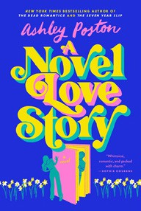

Matt Haig, Penguin, $18
  - Throne of Glass
Sarah J. Maas, Bloomsbury Publishing, $19
  - A Novel Love Story
Ashley Poston, Berkley, $19

Debut
On the Rise Indies Introduce

