July 24, 2024


For the week ending July 21, 2024 based on sales in hundreds of independent bookstores nationwide.
CHILDREN’S

RANK | SERIES

RANK | ILLUSTRATED

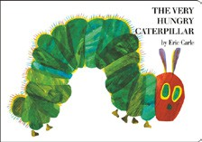
- The Very Hungry Caterpillar
Eric Carle, World of Eric Carle, $10.99
- Taylor Swift: A Little Golden Book Biography
Wendy Loggia, Elisa Chavarri (Illus.), Golden Books,
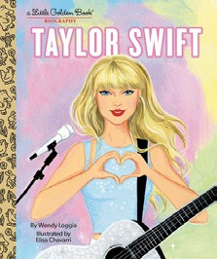

$5.99
- Goodnight Moon
Margaret Wise Brown, Clement Hurd (Illus.), Harper,
$10.99
- Where’s Waldo?
Martin Handford, Candlewick, $8.99
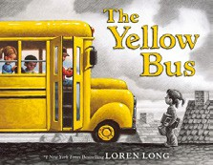

- The Yellow Bus
Loren Long, Roaring Brook Press, $19.99
- Millie Fleur’s Poison Garden
Christy Mandin, Orchard Books, $18.99
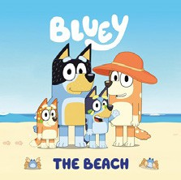

- Bluey: The Beach
Penguin Young Readers, $4.99
- Where’s Waldo Now?
Martin Handford, Candlewick, $8.99
- Blueberries for Sal
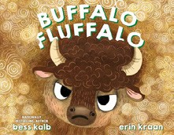

Robert McCloskey, Puffin, $8.99
- Where the Wild Things Are
Maurice Sendak, Harper, $21.99
- Dragon’s First Taco
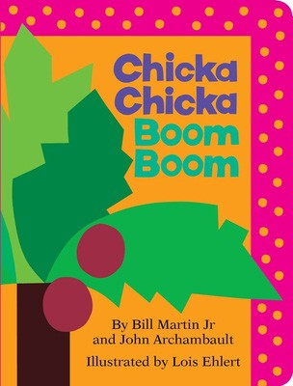

Adam Rubin, Daniel Salmieri (Illus.), Dial Books, $8.99
- Bluey: The Pool
Penguin Young Readers, $4.99
- Buffalo Fluffalo
Bess Kalb, Erin Kraan (Illus.), Random House Studio, $18.99
- Chicka Chicka Boom Boom
Bill Martin, Jr., John Archambault, Lois Ehlert (Illus.), Little Simon, $7.99
- Where’s Waldo? The Totally Essential Travel Collection
Martin Handford, Candlewick, $14.99
  - Dog Man (hardcover)
Dav Pilkey, Graphix


  - Diary of a Wimpy Kid (hardcover)
Jeff Kinney, Amulet
  - A Good Girl’s Guide to Murder
Holly Jackson, Ember
  - Elephant & Piggie (hardcover)
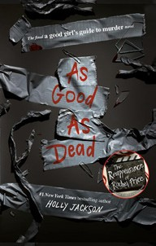

Mo Willems, Hyperion
  - Wings of Fire
Tui T. Sutherland, Scholastic
  - Percy Jackson and the Olympians
Rick Riordan, Hyperion
  - The Bad Guys (paperback)
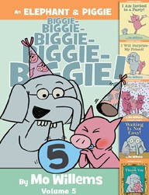

Aaron Blabey, Scholastic
  - I Survived
Lauren Tarshis, Brian Churilla (Illus.), Scholastic
  - Wild Robot
Peter Brown, Little, Brown Books for Young Readers
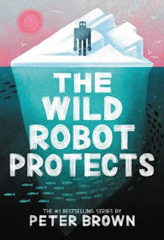

  - Magic Tree House
Mary Pope Osborne, Sal Murdocca (Illus.), Random House Books for Young Readers

All Fiction Series titles are hardcover and paperback unless noted.
Debut


Indies Introduce

OTHER CHILDREN’S INDIE FAVORITES
AGES 4 TO 8
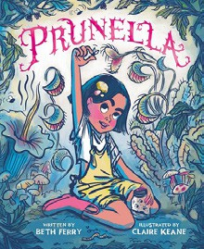

Prunella
Beth Ferry, Claire Keane (Illus.), Simon & Schuster Books for Young Readers, $18.99
“A tender story of being different and finding your perfect genus in a sea of dissimilar species. Makes me want a purple thumb — or maybe I already have one.”
—Stephanie Staton, CoffeeTree Books, Morehead, KY

