RANK | FICTION
- The Women




Kristin Hannah, St. Martin’s Press, $30
- The God of the Woods
Liz Moore, Riverhead Books, $30
- James
Percival Everett, Doubleday, $28

- All Fours
Miranda July, Riverhead Books, $29
- Long Island Compromise
Taffy Brodesser-Akner, Random House, $30
- Funny Story
Emily Henry, Berkley, $29

- Sandwich
Catherine Newman, Harper, $26.99
- A Death in Cornwall
Daniel Silva, Harper, $32
- The Ministry of Time
Kaliane Bradley, Avid Reader Press/Simon & Schuster,

$28.99
- The Spellshop
Sarah Beth Durst, Bramble, $29.99
- Swan Song
Elin Hilderbrand, Little, Brown and Company, $30
- The Midnight Feast

Lucy Foley, William Morrow, $30
- The Briar Club
Kate Quinn, William Morrow, $28.99
- All the Colors of the Dark
Chris Whitaker, Crown, $30
- The Cliffs
J. Courtney Sullivan, Knopf, $29
July 17, 2024
For the week ending July 14, 2024 based on sales in hundreds of independent bookstores nationwide.
HARDCOVER

RANK | NONFICTION
  - The Demon of Unrest: A Saga of Hubris, Heartbreak, and Heroism at the Dawn of the Civil War


Erik Larson, Crown, $35
  - The Anxious Generation
Jonathan Haidt, Penguin Press, $30
  - On Call: A Doctor’s Journey in Public Service
Anthony Fauci, M.D., Viking, $36


  - The Creative Act: A Way of Being
Rick Rubin, Penguin Press, $32
  - The Wager
David Grann, Doubleday, $30
  - An Unfinished Love Story

Doris Kearns Goodwin, Simon & Schuster, $35
  - Atomic Habits
James Clear, Avery, $27
  - The Friday Afternoon Club: A Family Memoir
Griffin Dunne, Penguin Press, $30
  - Democracy in Retrograde: How to Make Changes Big and Small in Our Country and in Our Lives
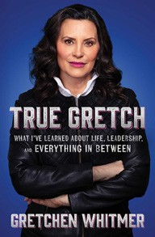

Sami Sage, Emily Amick, Gallery Books, $28.99
  - In My Time of Dying
Sebastian Junger, Simon & Schuster, $27.99
  - The Light Eaters
Zoë Schlanger, Harper, $29.99
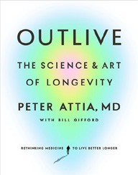
  - True Gretch: What I’ve Learned About Life, Leadership, and Everything in Between Gretchen Whitmer, Simon & Schuster, $26.99
  - Democracy or Else
Jon Favreau, Jon Lovett, Tommy Vieto, Zando-Crooked Media Reads, $28
  - Outlive: The Science and Art of Longevity
Peter Attia, M.D., Bill Gifford, Harmony, $32
  - The Wide Wide Sea
Hampton Sides, Doubleday, $35

OTHER HARDCOVER INDIE FAVORITES
Debut
On the Rise

Indies Introduce

Masquerade
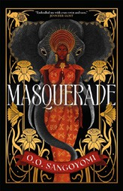

O. O. Sangoyomi, Forge Books, $27.99
“I love this historical novel that is full of West African mythology. Epic in feel but self-contained, it runs the full range of emotions. I love the creativity and descriptive writing, and can’t wait to see what Sangoyomi writes next.”
—Jamie Southern, Bookmarks, Winston-Salem, NC
Midnight Rooms: A Novel
Donyae Coles, Amistad, $28


“I’ve never read horror like this before, and I’m excited to see more and more BIPOC authors step boldly into this genre. I can’t wait to see what else Donyae Coles comes out with. Whatever it is, it’s on my autobuy list!”
—Shakeria Green, Lark and Owl Booksellers, Georgetown, TX

