RANK | HARDCOVER

- The Women




Kristin Hannah, St. Martin’s Press, $30
- The God of the Woods
Liz Moore, Riverhead Books, $30
- James
Percival Everett, Doubleday, $28

- All Fours
Miranda July, Riverhead Books, $29
- Long Island Compromise
Taffy Brodesser-Akner, Random House, $30
- Funny Story
Emily Henry, Berkley, $29

- Sandwich
Catherine Newman, Harper, $26.99
- A Death in Cornwall
Daniel Silva, Harper, $32
- The Ministry of Time
Kaliane Bradley, Avid Reader Press/Simon & Schuster,

$28.99
- The Spellshop
Sarah Beth Durst, Bramble, $29.99
- Swan Song
Elin Hilderbrand, Little, Brown and Company, $30
- The Midnight Feast

Lucy Foley, William Morrow, $30
- The Briar Club
Kate Quinn, William Morrow, $28.99
- All the Colors of the Dark
Chris Whitaker, Crown, $30
- The Cliffs
J. Courtney Sullivan, Knopf, $29
July 17, 2024
For the week ending July 14, 2024 based on sales in hundreds of independent bookstores nationwide.
FICTION

RANK | PAPERBACK
- Tomorrow, and Tomorrow, and Tomorrow


Gabrielle Zevin, Vintage, $19
- A Court of Thorns and Roses
Sarah J. Maas, Bloomsbury Publishing, $19
- Just for the Summer
Abby Jimenez, Forever, $17.99
- Happy Place


Emily Henry, Berkley, $19
- Not in Love
Ali Hazelwood, Berkley, $19
- The Housemaid Is Watching
Freida McFadden, Poisoned Pen Press, $17.99
- The Housemaid
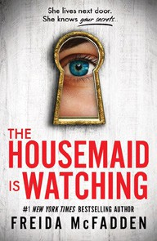

Freida McFadden, Grand Central, $12.99
- A Court of Mist and Fury
Sarah J. Maas, Bloomsbury Publishing, $19
- A Novel Love Story
Ashley Poston, Berkley, $19
- The Seven Husbands of Evelyn Hugo
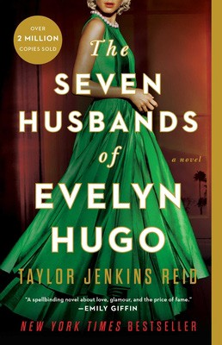

Taylor Jenkins Reid, Atria, $17
- This Summer Will Be Different
Carley Fortune, Berkley, $19
- Lady Tan’s Circle of Women
Lisa See, Scribner, $18.99
- The Midnight Library
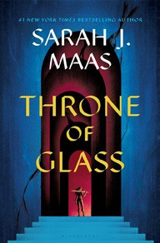

Matt Haig, Penguin, $18
- It Ends with Us
Colleen Hoover, Atria, $16.99
- Throne of Glass
Sarah J. Maas, Bloomsbury Publishing, $19

Debut
On the Rise Indies Introduce

