July 17, 2024


For the week ending July 14, 2024 based on sales in hundreds of independent bookstores nationwide.
CHILDREN’S

RANK | SERIES

RANK | ILLUSTRATED

- Goodnight Moon
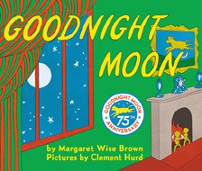

Margaret Wise Brown, Clement Hurd (Illus.), Harper,
$10.99
- Millie Fleur’s Poison Garden
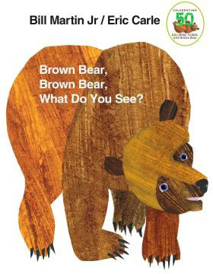
Christy Mandin, Cartwheel Books, $18.99
- Where’s Waldo?
Martin Handford, Candlewick, $8.99
- The Very Hungry Caterpillar
Eric Carle, World of Eric Carle, $10.99
- Taylor Swift: A Little Golden Book Biography
Wendy Loggia, Elisa Chavarri (Illus.), Golden Books,
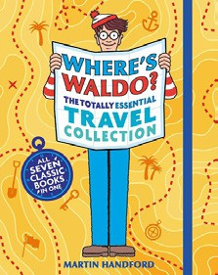

$5.99
- The Yellow Bus
Loren Long, Roaring Brook Press, $19.99
- Bluey: The Pool
Penguin Young Readers, $4.99
- Where the Wild Things Are
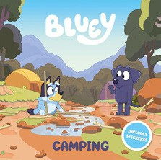

Maurice Sendak, Harper, $21.99
- Bluey: The Beach
Penguin Young Readers, $4.99
- Brown Bear, Brown Bear, What Do You See? Bill Martin, Jr., Eric Carle (Illus.), Henry Holt and Co. BYR, $8.99
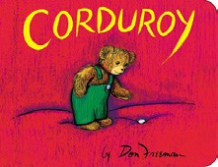

- Dragon’s First Taco
Adam Rubin, Daniel Salmieri (Illus.), Dial Books, $8.99
- Where’s Waldo? The Totally Essential Travel Collection
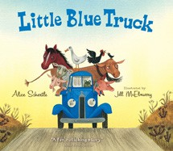

Martin Handford, Candlewick, $14.99
- Bluey: Camping
Penguin Young Readers, $5.99
- Corduroy
Don Freeman, Viking Children’s Books, $7.99
- Little Blue Truck
Alice Schertle, Jill McElmurry (Illus.), Clarion Books,
$10.99
  - Dog Man (hardcover)
Dav Pilkey, Graphix


  - Diary of a Wimpy Kid (hardcover)
Jeff Kinney, Amulet
  - Wings of Fire
Tui T. Sutherland, Scholastic
  - The Bad Guys (paperback)
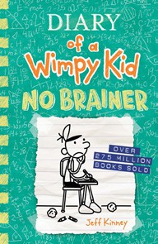

Aaron Blabey, Scholastic
  - A Good Girl’s Guide to Murder
Holly Jackson, Ember
  - Elephant & Piggie (hardcover)
Mo Willems, Hyperion
  - Percy Jackson and the Olympians


Rick Riordan, Hyperion
  - I Survived
Lauren Tarshis, Brian Churilla (Illus.), Scholastic
  - Magic Tree House
Mary Pope Osborne, Sal Murdocca (Illus.), Random House Books for Young Readers
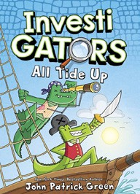

  - InvestiGators
John Patrick Green, Christopher Hastings, Pat Lewis (Illus.), First Second

All Fiction Series titles are hardcover and paperback unless noted.
Debut


Indies Introduce

OTHER CHILDREN’S INDIE FAVORITES
AGES 4 TO 8
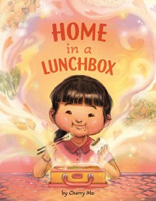

Home in a Lunchbox
Cherry Mo, Penguin Workshop, $18.99
“This story is brimming with rich and warm illustrations that invite you to discover the unifying power of food: how the simple act of sharing a meal with others can create and invoke belonging and community.”
—Courtney Roach, The Novel Neighbor, Webster Groves, MO

