RANK | FICTION
- Not in Love




Ali Hazelwood, Berkley, $19
- A Court of Thorns and Roses
Sarah J. Maas, Bloomsbury Publishing, $19
- Just for the Summer
Abby Jimenez, Forever, $17.99
- Happy Place


Emily Henry, Berkley, $19
- The Housemaid Is Watching
Freida McFadden, Poisoned Pen Press, $17.99
- This Summer Will Be Different
Carley Fortune, Berkley, $19
- Lady Tan’s Circle of Women
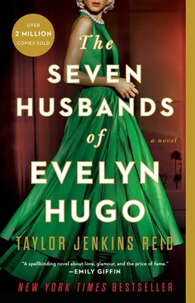

Lisa See, Scribner, $18.99
- A Court of Mist and Fury
Sarah J. Maas, Bloomsbury Publishing, $19
- The Midnight Library
Matt Haig, Penguin, $18
- The Seven Husbands of Evelyn Hugo
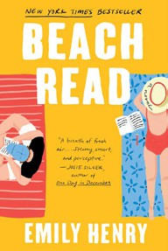

Taylor Jenkins Reid, Atria, $17
- The Housemaid
Freida McFadden, Grand Central, $12.99
- Beach Read
Emily Henry, Berkley, $16
- Summer Romance
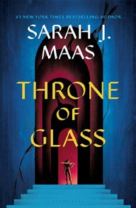

Annabel Monaghan, G.P. Putnam’s Sons, $19
- Throne of Glass
Sarah J. Maas, Bloomsbury Publishing, $19
- Crook Manifesto
Colson Whitehead, Vintage, $18

OTHER PAPERBACK INDIE FAVORITES
Out of the Sierra: A Story of Rarámuri Resistance


Victoria Blanco, Coffee House Press, $19.95
“A delicately told account of the Rarámuri, a Native people of Mexico, that honors their history, traditions, and culture, and one family’s story as they adapt to modern Mexican life. Poetic yet journalistic, dramatic yet quiet, devastating but hopeful.”
—Luis Correa, Avid Bookshop, Athens, GA
June 26, 2024
For the week ending June 23, 2024 based on sales in hundreds of independent bookstores nationwide.
PAPERBACK

RANK | NONFICTION
  - The Hundred Years’ War on Palestine: A History of Settler Colonialism and Resistance, 1917—2017


Rashid Khalidi, Metropolitan Books, $19.99
  - Braiding Sweetgrass
Robin Wall Kimmerer, Milkweed Editions, $20

  - What an Owl Knows
Jennifer Ackerman, Penguin, $19
  - All About Love: New Visions
bell hooks, Morrow, $16.99
  - Killers of the Flower Moon
David Grann, Vintage, $18
  - The Body Keeps the Score


Bessel van der Kolk, M.D., Penguin, $19
  - Crying in H Mart: A Memoir
Michelle Zauner, Vintage, $17
  - Poverty, by America
Matthew Desmond, Crown, $20
  - Everything I Know About Love: A Memoir


Dolly Alderton, Harper Perennial, $18.99
  - You Could Make This Place Beautiful
Maggie Smith, Atria/One Signal Publishers, $19.99
  - The Backyard Bird Chronicles
Amy Tan, Knopf, $35
  - A Fever in the Heartland: The Ku Klux Klan’s Plot to Take Over America, and the Woman Who Stopped Them
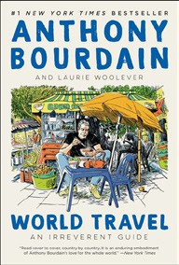

Timothy Egan, Penguin, $18
  - World Travel: An Irreverent Guide
Anthony Bourdain, Laurie Woolever, Ecco, $22
  - The Four Agreements
Don Miguel Ruiz, Amber-Allen, $12.95
  - Think Again
Adam Grant, Penguin, $20 Debut
On the Rise

MASS MARKET Indies Introduce
- Dune Frank Herbert, Ace, $10.99
- 1984 George Orwell, Signet, $9.99
- Dune Messiah Frank Herbert, Ace, $9.99
- The Way of Kings Brandon Sanderson, Tor, $11.99
- Camino Island John Grisham, Anchor, $9.99
- The Paris Apartment Lucy Foley, William Morrow, $10.99
- The 6:20 Man David Baldacci, Grand Central, $10.99
- Mistborn: The Final Empire Brandon Sanderson, Tor, $10.99
- Lord of the Flies William Golding, Penguin, $12
- Good Omens Neil Gaiman, Terry Pratchett, Morrow, $9.99

